A Cub Scout Odyssey

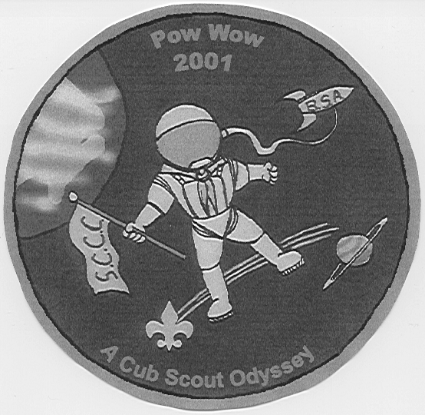

2001 POWWOW

Santa Clara County Council

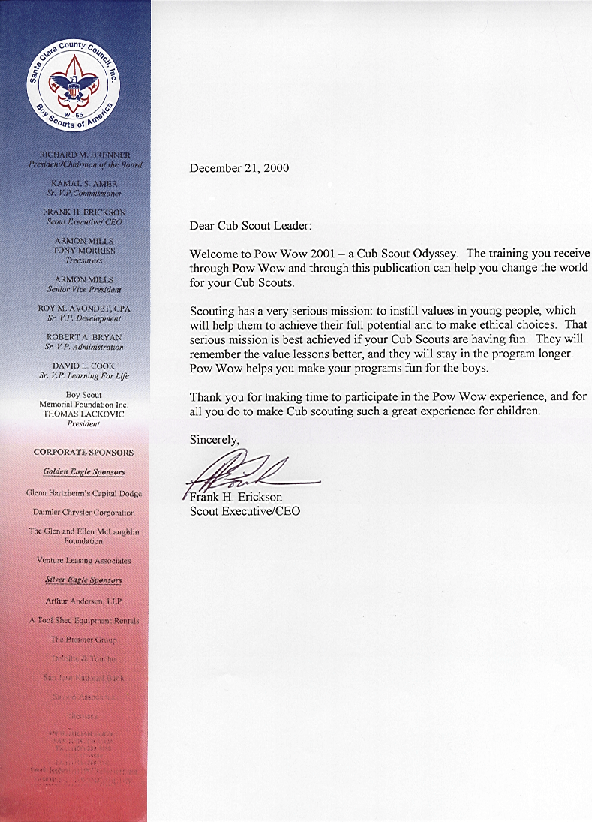

Santa Clara County Council Pow Wow
2001: A Cub Scout Odyssey

STAFF AND FACULTY

POW WOW CHAIR Sakiko Wehrman
PROFESSIONAL ADVISOR “J” Anderson
POW WOW CORE STAFF
Classes, Faculty Walt Stephenson
Facilities Frank Diaz
Publicity Adriana Rangel
Midway Frank Eng
Registration Nancy Backman
Service Support Linda Idemoto
Book “Grouch” Leslie Gibbons

SUPPORT STAFF
Child Care

First Aid Scott Morse
Lunch, Snack Kevin Pung and Venturing Crew 271
Boy Scout Team Scoutmasters Scott Bostic, Gary Backman
Boy Scouts from Troops 218, 342, 394
Patch Design Austin Donk
Paul Hagen (computer image)
General Help Phil Wehrman

GENERAL ADVISE Donna White, Linda Idemoto

POW WOW BOOK
Editors Sakiko and Phil Wehrman
Staff, Contributors Nancy Backman, Mary Bujalski, Emmette Craver,
Merrin Davidson, Leslie Gibbons, Dick Noack,
Ayako Southall, Alan Wehrman, Sean Wehrman,
Wesley Wong
CD production Emmette Craver, Kip Davidson, Leslie Gibbons,

Phil Wehrman, Wesley Wong

POW WOW FACULTY

Academics & Sports David Manley
Ask a Professional “J” Anderson
Boy Behavior David Sanchez
Cooking--In the Kitchen Cindy Smith, Richard Smith
Cooking--Outdoors Emmette Craver, Leslie Gibbons
Crafts--Leathercraft Tor Sivertstol, Roseanne Sivertstol
Crafts--Low Cost Deenna Ferry
Crafts--Preserving CS Memories Duon Zeroun
Crafts--Wolf & Bear Themes Adriana Rangel
Crafts--Working with Woods Bill Flood
Cub Dens on the Go Kassie Goldsworth
Cub Scouting with Disabilities Tracy Marr
Den Ceremony/Gathering Activities Jim Fuller
Derbies Steve Ricossa
Duty to God Ann Resch, George Imokawa,
Jose Saleme, Willis Clayton
Family Enrichment David Manley
First Aid for Leaders Laura Rodriques
Fundraisers & Finance Chuck Guthery
Games Kyna Hendra, Marcia Morrow
Knives Kim Thurgate, Mike Berryhill
LDS Scouting Mike Davis, Judy Johnson, Corleen Rogers
Nature--Webelos Jacob Bender
Nature--Wolf & Bear Jacob Bender
Neckerchief Slides Walt Stephenson, Jim Pierce, LeAnn Popp
Our Flag Roberta Pitsenbarger
Outdoor Resources Stan Kawamata
Pack Ceremonies Charlie Schenck
Pack Meeting Planning Garry Holst
Rechartering Made Easy Bill Ritt
Rocket Derbies Wesley Wong, Judy Levy
Rocket Fun Wesley Wong, Judy Levy
Science Sean Wehrman, Neal Gossard
Selecting Quality CS Leaders Dolores Bergen
Showman & CS Band Judy Johnson
Songs for New Leaders Ken Leja, Carmen Ross
Tied up in Knots Kim Thurgate, Tim Thurgate
Webelos Activity Badges, Webelos Badge, Arrow of Light
Megan Mork, Jay Isaccson, Mary Bujalski,
Daryl Milanowski
Webelos Program for LDS Dens Ruth Packard, Dennis Packard

WEST George Booth, Dave Filomeo

My heart-felt thanks to the staff and faculty and also to all those people who gave me ideas, advice and encouragement. Thank you!
-Sakiko Wehrman-
NOTES FROM THE EDITORS

As the Cub Scout Leaders Pow Wow is a supplemental training, the Pow Wow book is supplemental to the basic literature suggested to the leaders. As such we tried, in general, to avoid repeating materials listed in the following BSA publications: Cub Scout Leader Book, Cub Scout Leader How-To Book, Cub Scout Ceremonies for Dens and Packs, Cub Scout Program Helps 2000-2001, Cub Scout Songbook, Webelos Leader Book, and Tiger Cub Resource Book. Whenever possible we supplied the reference to specific items in these books.

This year we tried to include some on-line resources. We are sure there are more out there and some must be more appropriate to the themes. What we put in here are just samples, places for the leaders to start searching. There is plenty out there for Cub Scout leaders to use.

Materials in this book come from various sources--some of them have been around for years, some come from other councils and some others are brand new, created by people in this council.

The Pow Wow book staff and contributors and CD production staff were just wonderful. They stepped in whenever and wherever their help was needed, even in the busy month of December. Thank you so much, Leslie, Wesley, Nancy, Mary, Emmette, Merrin, Dick, Ayako, and Kip. Our sons Sean and Alan were more involved this year in the book editing. They verified phone numbers and websites, helped in proofreading, sifted materials and created some puzzles.

Walt Stephenson was a great support. As in the five previous books, Walt listened to our concerns, excitement and frustrations and gave us encouragement.

And finally the Editor’s Lament--
Putting together this Pow Wow book is no picnic.
If we print jokes, people say we are light-minded.
If we don’t they say we are too serious.
If we publish original material, they say we lack variety.
If we publish things from other books, we are too lazy to write our own.
If we don’t print all contributions, then we lack proper appreciation of other people.
If we do, the book may be a mess.
Probably someone will say that we copied this lament from some other book.
We did.

Our thanks to the editors of the Pow Wow books from Utah National Parks Council, Great Salt Lake Council, Golden Empire Council, Great Saulk Trail Council, Chief Seattle Council, Pacific Harbor Council, Grand Teton Council, Sam Houston Council, Circle Ten Council, Indian Nations Council, Last Frontier Council, Grand Canyon Council, Baltimore Area Council, Cascade Pacific Council, San Gabriel Valley/Verdugo Hills/Long Beach Councils, San Francisco Council, Monterey Bay Area Council as well as past editors of our council’s Pow Wow books.
Sakiko and Phil Wehrman

