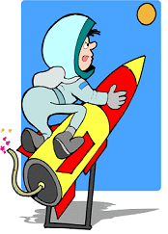
POW WOW 2005 -
Rocket Fun

Date: January 22, 2005
Course Session: Sessions 1, 4

Instructors: Wesley Wong,
Pioneer District, Cub Scout Roundtable
(408) 377-2859 (H)
wesley.wong@sbcglobal.net

Leslie Gibbons
Pioneer District, Cub Scout Roundtable

Objective: Learn how to make safe, simple non-fuel type rockets (paper, pencil, water rockets) to incorporate in your den or pack program.

On-line Resources:

- http://quest.arc.nasa.gov/space/teachers/rockets
- http://www.grc.nasa.gov/WWW/K-12/airplane/bgmr.html
- http://edtech.kennesaw.edu/web/solar.html
- http://www.water-rockets.com/javasim/index.html
- http://homes.managesoft.com.au/~cjh/rockets/links.html
- http://mpassero.tripod.com/rocket/index.htm

Rocket Pop! Launch Pad:

- http://www.everyoneslaser.com/rocketpop/rocketpop_sales.htm

Class Outline
I. Introduction (5')
- Distribute Handouts
- Sign-in Sheet
- Brief history of Rockets

II. Rocket Principles (3')
- Newton's 3 Laws of Motion
- Rocket Pinwheel

III. Incorporating into Den or Pack Program (5')
- Wolf, Bear, Webelos Achievements
- Space Theme
- Rocket Derby
- Rocket Derby Patches

IV. Rocket Safety (2')

V. Types of Rockets & Construction Tips (20')
A. Paper Rockets
B. Pencil Rockets
C. Air & Foam Rockets
D. Alka-Seltzer Rockets
- Basic Film Canister
- Canister with Fins & Nosecone
- Double canister
E. Water Rockets
- Basic Water bottle
- Water bottle with fins & nosecone
- Paper Tube rockets
- Florescent Tube rocket
- Launch Pads

VI. Rocket Construction (15')
- Form in groups of 5 people each
- Each group will build soda bottle rocket

VII. Rocket Launch. (10')
Den & Pack Activities with Rockets

Den Activities:
Wolf Elective 5g: Make a model rocket.
Bear Achievement 21f: Make a model of a rocket.
Elective 1d: Build a model of a rocket or space satellite.

Webelos Scientist 5: Show the effects of air pressure.
6: Show the effects of water & air pressure.
7: Build and launch a model rocket.

Pack Activities:
- Space Theme - Scout-O-Ramas
- Space Derby or Rocket Derby - Camporees
- Pack picnic or barbecue

Rocket Activities:
- Can be used in the den, the Pack or classroom.
- Can be incorporated in the Webelos Scientist badge.
- Can illustrate the effects of air pressure and water pressure
- Can be used to teach the scientific method. Experiment with different amounts of water and chart the launch times vs. water level. Experiment with different fin designs and see which ones give the best flight.
- Foster creativity and exploration. Give materials to the boys without any directions, and have them put together a rocket they think will fly the highest. Explore options for recovery systems such as parachutes.

Rocket Safety Tips

Construction Safety Precautions:

- Always use glue in a well-ventilated area.
- Cover the work area with paper or a cloth in case glue drips.

Pressure Testing Water Rockets:

- Never use glass bottles for water rockets.
- Always fill rocket completely with water when pressure testing. This will reduce the explosive hazard of the compressed air.
- Pressurize slowly, and if possible open the air pressure valve so that the air bubbles slowly into the rocket. Then back away and wait for the pressure to stabilize in the rocket with no more bubble action.

Launch Safety Precautions:

- Never launch a rocket over 400ft without FAA clearance.
- Never launch in a crowded area.
- Choose an open field that is clear of obstructions such as trees and wires.

- Never stand directly over the launch pad while setting rocket on pad or during launch.
- Have each student or student group set up their own rocket on the launch pad. Other students should stand back several meters. It will be easier to keep observers away by roping off the launch site.
- Only permit the students launching the rocket to retrieve it.
- The student pressurizing the rocket should put on eye protection (safety goggles).

- Launch under low pressure first.
- Launch under zero or gentle breeze conditions.
- Place the launcher in the center of the field and anchor it in place with the spikes or tent stakes.
- When pressurization is complete, all students should stand in back of the rope for the countdown. Launch the rocket when the recovery range is clear.
Rocket Principles

Newton's First Law
This law of motion is just an obvious statement of fact.

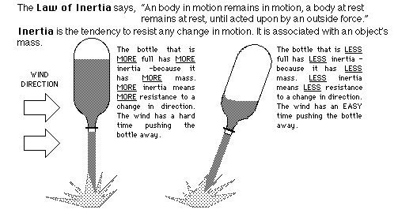

Newton's Second Law
This law of motion is essentially a statement of a mathematical equation. The three parts of the equation are mass (m), acceleration (a), and force (f).

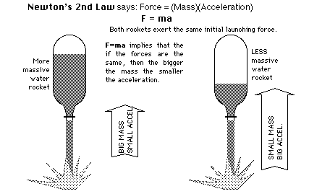

Newton's Third Law
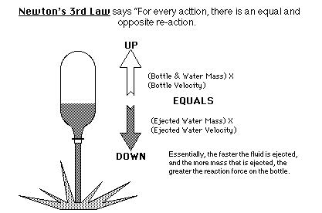

Putting Newton's Laws of Motion Together
An unbalanced force must be exerted for a rocket to lift off from a launch pad or for a craft in space to change speed or direction (First Law). The amount of thrust (force) produced by a rocket engine will be determined by the rate at which the mass of the rocket fuel burns and the speed of the gas escaping the rocket (Second Law). The reaction, or motion, of the rocket is equal to and in the opposite direction of the action, or thrust, from the engine (Third Law).

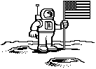
Rocket Pinwheel

TOPIC: Action-Reaction Principle
DESCRIPTION: Construct a balloon- powered pinwheel.

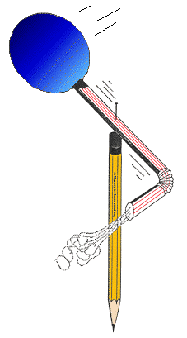
"MATERIALS:
- Wooden pencil with an eraser on one end
- Sewing pin
- Round party balloon
- Flexible soda straw
- Plastic tape

METHOD:
- Inflate the balloon to stretch it out a bit.

- Slip the nozzle end of the balloon over the end of the straw farthest away from the bend. Use a short piece of plastic tape to seal the balloon to the straw. The balloon should inflate when you blow through the straw.

- Bend the opposite end of the straw at a right angle.

- Lay the straw and balloon on an outstretched finger so that it balances and mark the balance point. Push the pin through the straw at the balance point and then continue pushing the pin into the eraser of the pencil and finally into the wood itself.

- Spin the straw a few times to loosen up the hole the pin has made.

- Blow in the straw to inflate the balloon and then let go of the straw.

DISCUSSION: The balloon-powered pinwheel spins because of the action-reaction principle described in Newton's Third Law of Motion. Stated simply, the law says every action is, accompanied by an opposite and equal reaction. In this case, the balloon produces an action by squeezing on the air inside causing it to rush out the straw. The air, traveling around the bend in the straw, imparts a reaction force at a right angle to the straw. The result is that the balloon and straw spins around the pin.

Paper Rocket

TOPIC: Stability
DESCRIPTION: Small flying rockets to make out of paper and propel with air blown through a straw.
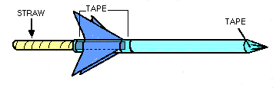
"
MATERIALS:
- Scrap bond paper
- Cellophane tape
- Scissors
- Sharpened fat pencil
- Milkshake straw (slightly thinner than pencil)

PROCEDURE:

- Cut a narrow rectangular strip of paper about 5 inches long and roll it tightly around the fat pencil. Tape the cylinder and remove it from the pencil.

- Cut crown points into one end of the cylinder and slip it back onto the pencil.

- Slide the crown points to the pencil tip and squeeze the points together and tape them together to seal the end to form a nose cone (the pencil point provides support for taping). An alternative to the crown points is to just fold over one end of the tube and seal it with tape.

- Remove the cylinder from the pencil and gently blow into the open end to check for leaks. If air easily escapes, use more tape to seal the leaks.

- Cut out two sets of fins using the pattern and fold according to instructions. Tape the fins near the open end of the cylinder. The tabs make taping easy.

FLYING THE PAPER ROCKET:
Slip the straw into the rocket's opening. Point the rocket towards a safe direction, sharply blow through the straw. The rocket will shoot away. Be careful not to aim the rocket towards anyone because the rocket could poke an eye.

DISCUSSION: Paper rockets demonstrate how rockets fly through the atmosphere and the importance of having fins for control. For experimental purposes, try building a rocket with no fins and one with the fins in the front to see how they will fly. Practice flying the rockets on a ballistic trajectory towards a target. Also try making a rocket with wings so that it will glide.
"Pencil Rocket

TOPIC: Rockets
DESCRIPTION: Rockets, using pencils for their bodies, are launched with a rubber band-powered launch platform.

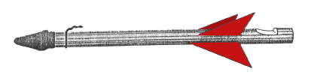
"
MATERIALS and TOOLS:
- 2 Pieces of wood 3'X4"Xl" in size
- 2 Cup hooks
- 1 Wooden spring clothes pin
- 1 Small wood screw
- 1 Screw eye
- 2 Metal angle irons and screws
- 4 Feet of heavy string
- Iron bailing wire (18 gauge minimum)
- Several rubber bands
- Several wooden pencils (unsharpened)
- Several pencil cap erasers
- Cellophane or masking tap
- Heavy paper
- Saw
- Wood file
- Drill (3/16 inch diameter)
- Pliers

PROCEDURE
Launch Platform

- Join the two pieces of wood as shown in the diagram to form the launch platform. Use a metal angle iron on each side to strengthen the structure.

- Screw in the cup hooks and screw eye into the wood in the places indicated in figure 1.

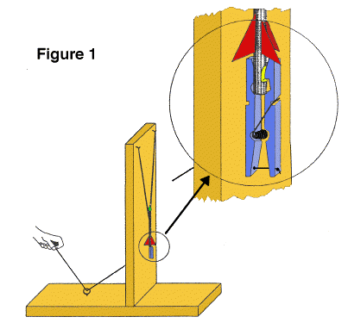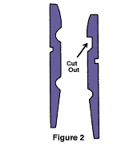

- Temporarily separate the wooden pieces of the clothes pin and file the "jaw" of one piece square as shown in figure 2. Drill two holes through the other wood piece as shown. Drill one hole through the first wood piece as shown.

- Drill a hole through the upright piece of the launch platform as shown and screw the clothes pin to it so that the lower hole in the pin lines up with the hole in the upright. Reassemble the clothes pin.

- Tie a knot in one end of the string and feed it through the clothes pin as shown in figure 1, through the upright piece of the platform and then through the screw eye. When the free end of the string is pulled, the clothes pin will pen. The clothes pin has become a rocket hold-down and release device.

- Loop four rubber bands together and loop their ends on the cup hooks. The launch platform is now complete.

Rocket

"
- Take a short piece of bailing wire and wrap it around the eraser end of the pencil about one inch from the end. Use pliers to twist the wire tightly so that it "bites" into the wood a bit. Next, bend the twisted ends into a hook as shown in figure 3.

- Take a sharp knife and cut a notch in the other end of the pencil as shown in figure 3.

- Cut out small paper rocket fins and tape them to the pencil just above the notch.

- Place an eraser cap over the upper end of the rocket. This blunts the nose to make the rocket safer if it hits something.

The rocket is now complete.

LAUNCHING PENCIL ROCKETS:
- Choose a wide-open outdoor area to launch the rockets.

- Spread open the jaw of the clothes pin and place the notched end of the rocket in the jaws. Close the jaws and gently pull the pencil upward to insure the rocket is secure. If the rocket doesn't fit, change the shape of the notch slightly.

- Pull the rubber bands down and loop them over the wire hook. Be sure not to look down over the rocket as you do this in case the rocket is prematurely released.

- Stand at the other end of the launcher and step on the wood to provide additional support.

- Make sure no one except yourself is standing next to the launch pad. Count down from 10 and pull the string. Step out of the way from the rocket as, it flies about 75 feet up in the air, gracefully turns upside down and returns to Earth.

- The rocket's terminal altitude can be adjusted by increasing or decreasing the tension on the rubber bands.

DISCUSSION: Like the flight of Robert Goddard's first liquid fuel rocket in 1926, the pencil rocket gets its upward thrust from its nose end rather than its tail. Regardless, the rocket's fins still provide stability, guiding the rocket upward for a smooth flight. If a steady wind is blowing during flight, the fins will steer the rocket towards the wind in a process called 'weather cocking.' On NASA rockets, active controls steer during flight to prevent weather cocking and to aim them on the right trajectory. Active controls include tilting nozzles and various forms of fins and vanes.

Alka-Seltzer Rockets
(By Mike Passerotti)

Purpose
To design a paper rocket propelled by Alka-Seltzer and water to demonstrate Newton's third law of motion.

Background
The paper rocket in this activity is propelled according to the principle stated in Isaac Newton's third law of motion: "For every action there is an opposite and equal reaction." Gas pressure builds inside the film canister due to the mixing of Alka-Seltzer and water. This action continues until enough pressure builds to blow apart the canister from its lid. The reaction is the launch of the rocket.

Materials
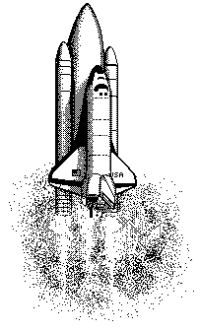
card stock printed pattern; empty film canister with lid that snaps inside; markers, crayons, or colored pencils; tape; glue; scissors; Alka-Seltzer tablets; water; metric tape measure or meter sticks; straw; (Optional launch pad: wood block, coat hanger or other stiff wire)

Preparation
Review and prepare materials. It is most important to use film canisters with lids that snap inside. Do not use lids that close around the outside of the canister.

Construction
- Cut the fins out. Cut the nose cone and body out as one piece.
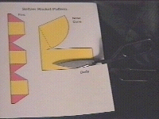
- Tape the body onto the film canister, roll the paper around the side, and tape the end down. The lid end of the film canister goes down.

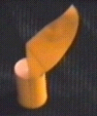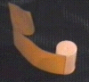

- Roll the nose cone around in the shape of a cone and tape it together. Straighten the nose cone point to the center of the rocket and tape it to the sides.

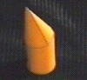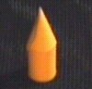

- Fold the fins so that the colored side is out. Tape or glue the fin halves together to form a complete circle.

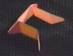

- Fold the fins so that the colored side is out. Tape or glue the fin halves together to form a complete circle.

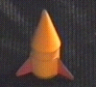
- Cut a 1-inch piece of straw and tape it to the body.

Launch Time
This is an outdoor activity. If gusty winds are a problem, then place a quarter in the canister to keep the rocket from falling over. Launching near a wall where a metric tape has been hung or where meter sticks have been stacked may make it easier to judge how high the rocket goes. You may want to wear safety glasses during this experiment as a general safety precaution. Everyone should stand away from loaded rockets when they are on the launch pad. It may take 15 to 20 seconds to build up enough pressure to launch, so a loaded rocket should not be approached prematurely. These rockets can shoot 5 meters or more into the air. No sharp objects should be placed on top of the nose cone or elsewhere on the rocket.

Make a launch pad with a block of wood and a straight piece of wire. Drill a hole for the wire and insert the wire straight up to guide the rocket at lift off.

Wrap-up
One way to record the results of different "fuel" mixtures is to make a simple graph of height vs. amount of water. Such a graph gives a clear, visual record of the observations and can be used as evidence to support interpretations.

Design and launch other rockets powered by two, three or more film canisters.

Design a two-stage rocket.

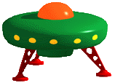

Soda Bottle Rockets

Materials
2 soda bottles; card stock printed pattern; markers, crayons, or colored pencils; tape; glue; scissors; water; wood block approximately 4" long piece of "2 by 4" lumber; one wood screw; one rubber automotive valve stem; bicycle tire pump.

Preparation
Review and prepare materials. Build the launch pad by cutting 2 1/2" off the cap end of the bottle. Cut a 3/8" slot down one side of the bottle for the tire pump hose. Drill or punch a hole in the bottom of the bottle. Screw the bottle to the block of wood.

Construction
1. Print the patterns. Cut the fins out. Cut the nose cone out.
2. Roll and tape the nose cone. Tape the nose cone to the bottom of the whole soda bottle.
3. Fold the fins at all the dotted lines. Glue or tape two of the fins together. Wrap the fins around the middle of the whole soda bottle and glue or tape the last fin together.

Launch Time
This is an outdoor activity. If gusty winds are a problem, then abort the launch. Everyone should stand away from rockets when they are on the launch pad. These rockets can shoot 100 feet or more into the air. No sharp objects should be placed on top of the nose cone or elsewhere on the rocket.
Fill the soda bottle a little less than half way with water. Shove the large end of the tire valve stem into the neck of the bottle. Attach the bicycle pump hose to the valve stem. Lower the bottle into the launch pad so that the hose slides down into the slot, the valve stem points down and the bottle rests on top of the cut bottle.

Pump up the bottle until it pops off the valve stem and flies to new heights.

Wrap-up
One way to record the results of different "fuel" mixtures is to make a simple graph of height vs. amount of water. Such a graph gives a clear, visual record of the observations and can be used as evidence to support interpretations.
Design and launch other rockets. Design a two-stage rocket. Design recovery mechanisms such as parachute, ribbon or propeller.

Soda Bottle Launch Pad

You can use a bicycle pump, soda bottle, one screw, a piece of 2x4 scrap and an automotive tire valve stem to create a launch pad.

- Take an empty soda bottle and cut it as shown below (left), cut the top off and cut a slot wide enough for the bicycle pump hose and deep enough to slide in the rocket, valve stem and bicycle pump hose fitting (the rocket should rest on the cut end of the soda bottle launch pad:

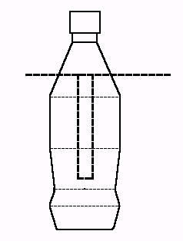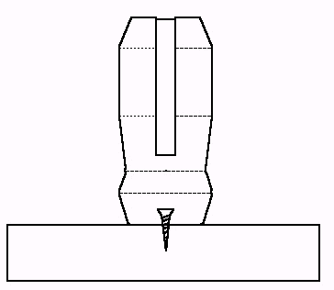

- Screw the soda bottle to a scrap piece of 2x4 as shown above (right).

- Shove the tire valve stem into the neck of your soda bottle rocket (Fig. 3).

- Attach the bicycle pump to the valve stem.

- Slide the soda bottle rocket with hose attached into the launch pad. See the finished pad ready to launch (Fig. 4).

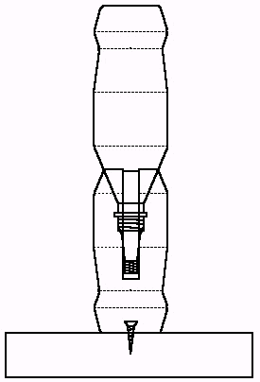Fig. 3 Fig. 4
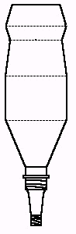
- Pump it up until it pops!

Water Rocket Derby

What is a Rocket Derby?

A rocket derby is a great summertime Pack activity that a scout can do with the whole family. It requires less preparation and setup than the propeller driven space derby kits. A rocket derby uses water rockets that are propelled with water and air pressure. The rockets are simple enough to assemble that Tiger Cubs and siblings age 4 and older can also participate. The scouts and parents get a great thrill at seeing their rockets fly skyward. The rockets can fly up to 50-60 feet in the air.
Solid fuel type rockets such as Estes rockets are beyond the capabilities of most Cub Scouts and are not recommended for a Cub Scout rocket derby.

Rocket Derby Kit

The basic rocket consists of an 18" mailing tube, a 20 oz. soda bottle, fins and a nosecone. Gather the materials well in advance.

Materials List:

18" cardboard mailing tube with tube cap | Small quantities of mailing tubes can be purchased from the post office of mailing supply stores (Mailboxes Etc.). Bulk quantities can be ordered from the internet at reduced prices. Papermart.com has some of the best prices. Cut the tube into a 12” section and 6” section.
20 oz. plastic soda bottle (empty) | Ask your local eating establishment or office building with a soda bottle vending machine if you can collect their empty soda bottles.
Poster board | Get these in a variety of bright colors for the nosecone.
Matte board | This is the thick cardboard used for framing pictures and photos. Some framing stores sell their scrap pieces for very low prices.
Fun Foam | This can be purchased at craft supply stores.

In addition to the above materials, you will also need lots of scissors and rolls of 2” wide clear packing tape. Color paper, stickers and markers can also be provided for decorating the rocket.

Derby Equipment & Supplies

- Safety Cones
- Wind Sock or Flag
- Bicycle Pump or Air Tank
- Water Buckets & Dish Pan
- Empty soda bottles

- Launch Pad: This will be the most expensive item required for the rocket derby. You will need a launch pad that is capable of handling up to 100 pounds of air pressure. You can construct your own launcher, or purchase one ready-made. There are several web sites on the internet that have construction plans, and launch pads for purchase. Most launch pads are constructed of PVC piping.

Rocket Construction

① Insert Cap
② Tape tubes together
③ Fold Cone & Tape

④ Center Cone & Tape to tube
⑤ Insert Bottle
⑥ Wrap foam strip around bottle & shove in tube

⑦ Seal Bottle in tube w/ tape

⑧ Attach fins at fin guides
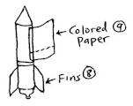

⑨ Tape color paper to tube, wrap tube & tape

 Attach Rocket ID sticker below cone. Decorate rocket!

These rockets are great for water rocket derbies. They are inexpensive to make, easy to construct and are quite durable. They are capable of reaching over 100 feet in height.

- Insert the tube cap onto the end of the 6" tube, which has 3 marks for the fin guides.
- Stack 12" tube onto capped end of short tube. Tape the tubes together.
- Shape the fan-shaped cardboard into a nosecone and tape together, making sure that the opening fits onto the cardboard tube.
- Center the nosecone onto the end of the 12" tube, and tape the nosecone onto the tube. Completely cover the nosecone with tape.
- Insert the plastic soda bottle into the 6" tube, with the opening sticking out.
- Wrap the strip of fun foam around the top of the bottle, and shove it into the cardboard tube. The fun foam keeps the bottle from moving around in the tube.
- Seal the bottle in tube with tape.
- Place each fin onto a fin guide on the 6" tube. The fin point should be pointing toward the nosecone. Tape fins SECURELY onto tube, and cover completely with tape.
- Wrap the rocket body with 1-1/2 sheets of color paper (will be provided), and tape onto the rocket. Tape the color paper to the tube before wrapping around tube.
- Attach Rocket ID Sticker below nosecone. Decorate rocket with markers, stickers, etc.

Tips for Running a Rocket Derby

- Plan event well in advance, set date and location (Park with large field).
- Prepare rocket kits in advance. Conduct workshop before event for assembling rockets, or build during a den or pack meeting.
- For competition, judge rockets for flight time (from lift-off to landing).
- Get volunteers (parents) for:
- Event Coordinator
- Time keeper (with stopwatch)
- Water fillers (to fill rockets)
- Launch crew (to operate the launch pads)
- Compress rockets to a maximum of 85 psi for competition (vary pressure based on wind and enviroment).
- Always following safety precautions!

Rocket Derby Staff

To run a smooth rocket derby, you must have enough adults to staff the event. Ask some of the parents to help, especially those who are not already Pack leaders. Here are some of the staff positions:

Registration (1) | This person will check in the scout, assign him a number, and inspect the rocket.
Time Keeper (1) | This person will record the time aloft for each rocket with a stopwatch.
Water Filler (1) | This person will assist each boy in filling the rockets with water (1/3 of the bottle is filled with water). Have on hand a bucket of water and extra 20 oz. bottles at the water station.
Launch Crew (2) | Two people are required at the launch pad. One person to place the rocket on the pad, and the other person to pump the air. An air tank can be used, but may lose pressure with continued use. A bicycle pump requires a lot of pumping, but is a cheaper alternative. Use a pressure gauge (can be attached to the launch pad, air tank or bicycle pump) to keep a consistent level of pressure for each launch. An ideal pressure is 85 psi.

Rocket Derby Competition

The main goal of the rocket derby is the same as the pinewood derby – for the scout to spend quality time with his parents constructing and launching the rockets, and to have fun! Participation is much more important than the competition itself.

- The rocket derby can be just a fun activity to spend a nice afternoon launching rockets.
- To add the spirit of competition, ribbons or prizes can be awarded for construction (coolest looking, most unusual, tallest, shortest, most space-age), and for flight (highest, longest time aloft).
- To measure height, several height gauges can be constructed and positioned at various spots away from the launch pad. An average height should be calculated to eliminate any bias from the readings.
- To measure time aloft, time the rocket from the time it leaves the launch pad until the first part of the rocket touches the ground. If time permits, launch the rockets 2 times, and calculate the total time to determine the winner. This is the easiest method for competitions.
- Have a separate division for the siblings.

Rocket Derby Patches

Patchsales.com has a couple of Rocket Derby patches available. Visit www.patchsales.com and search for “Rocket Derby.” These patches are reasonably priced and can be awarded for participation in the rocket derby.
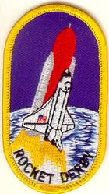

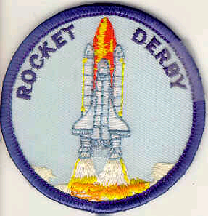

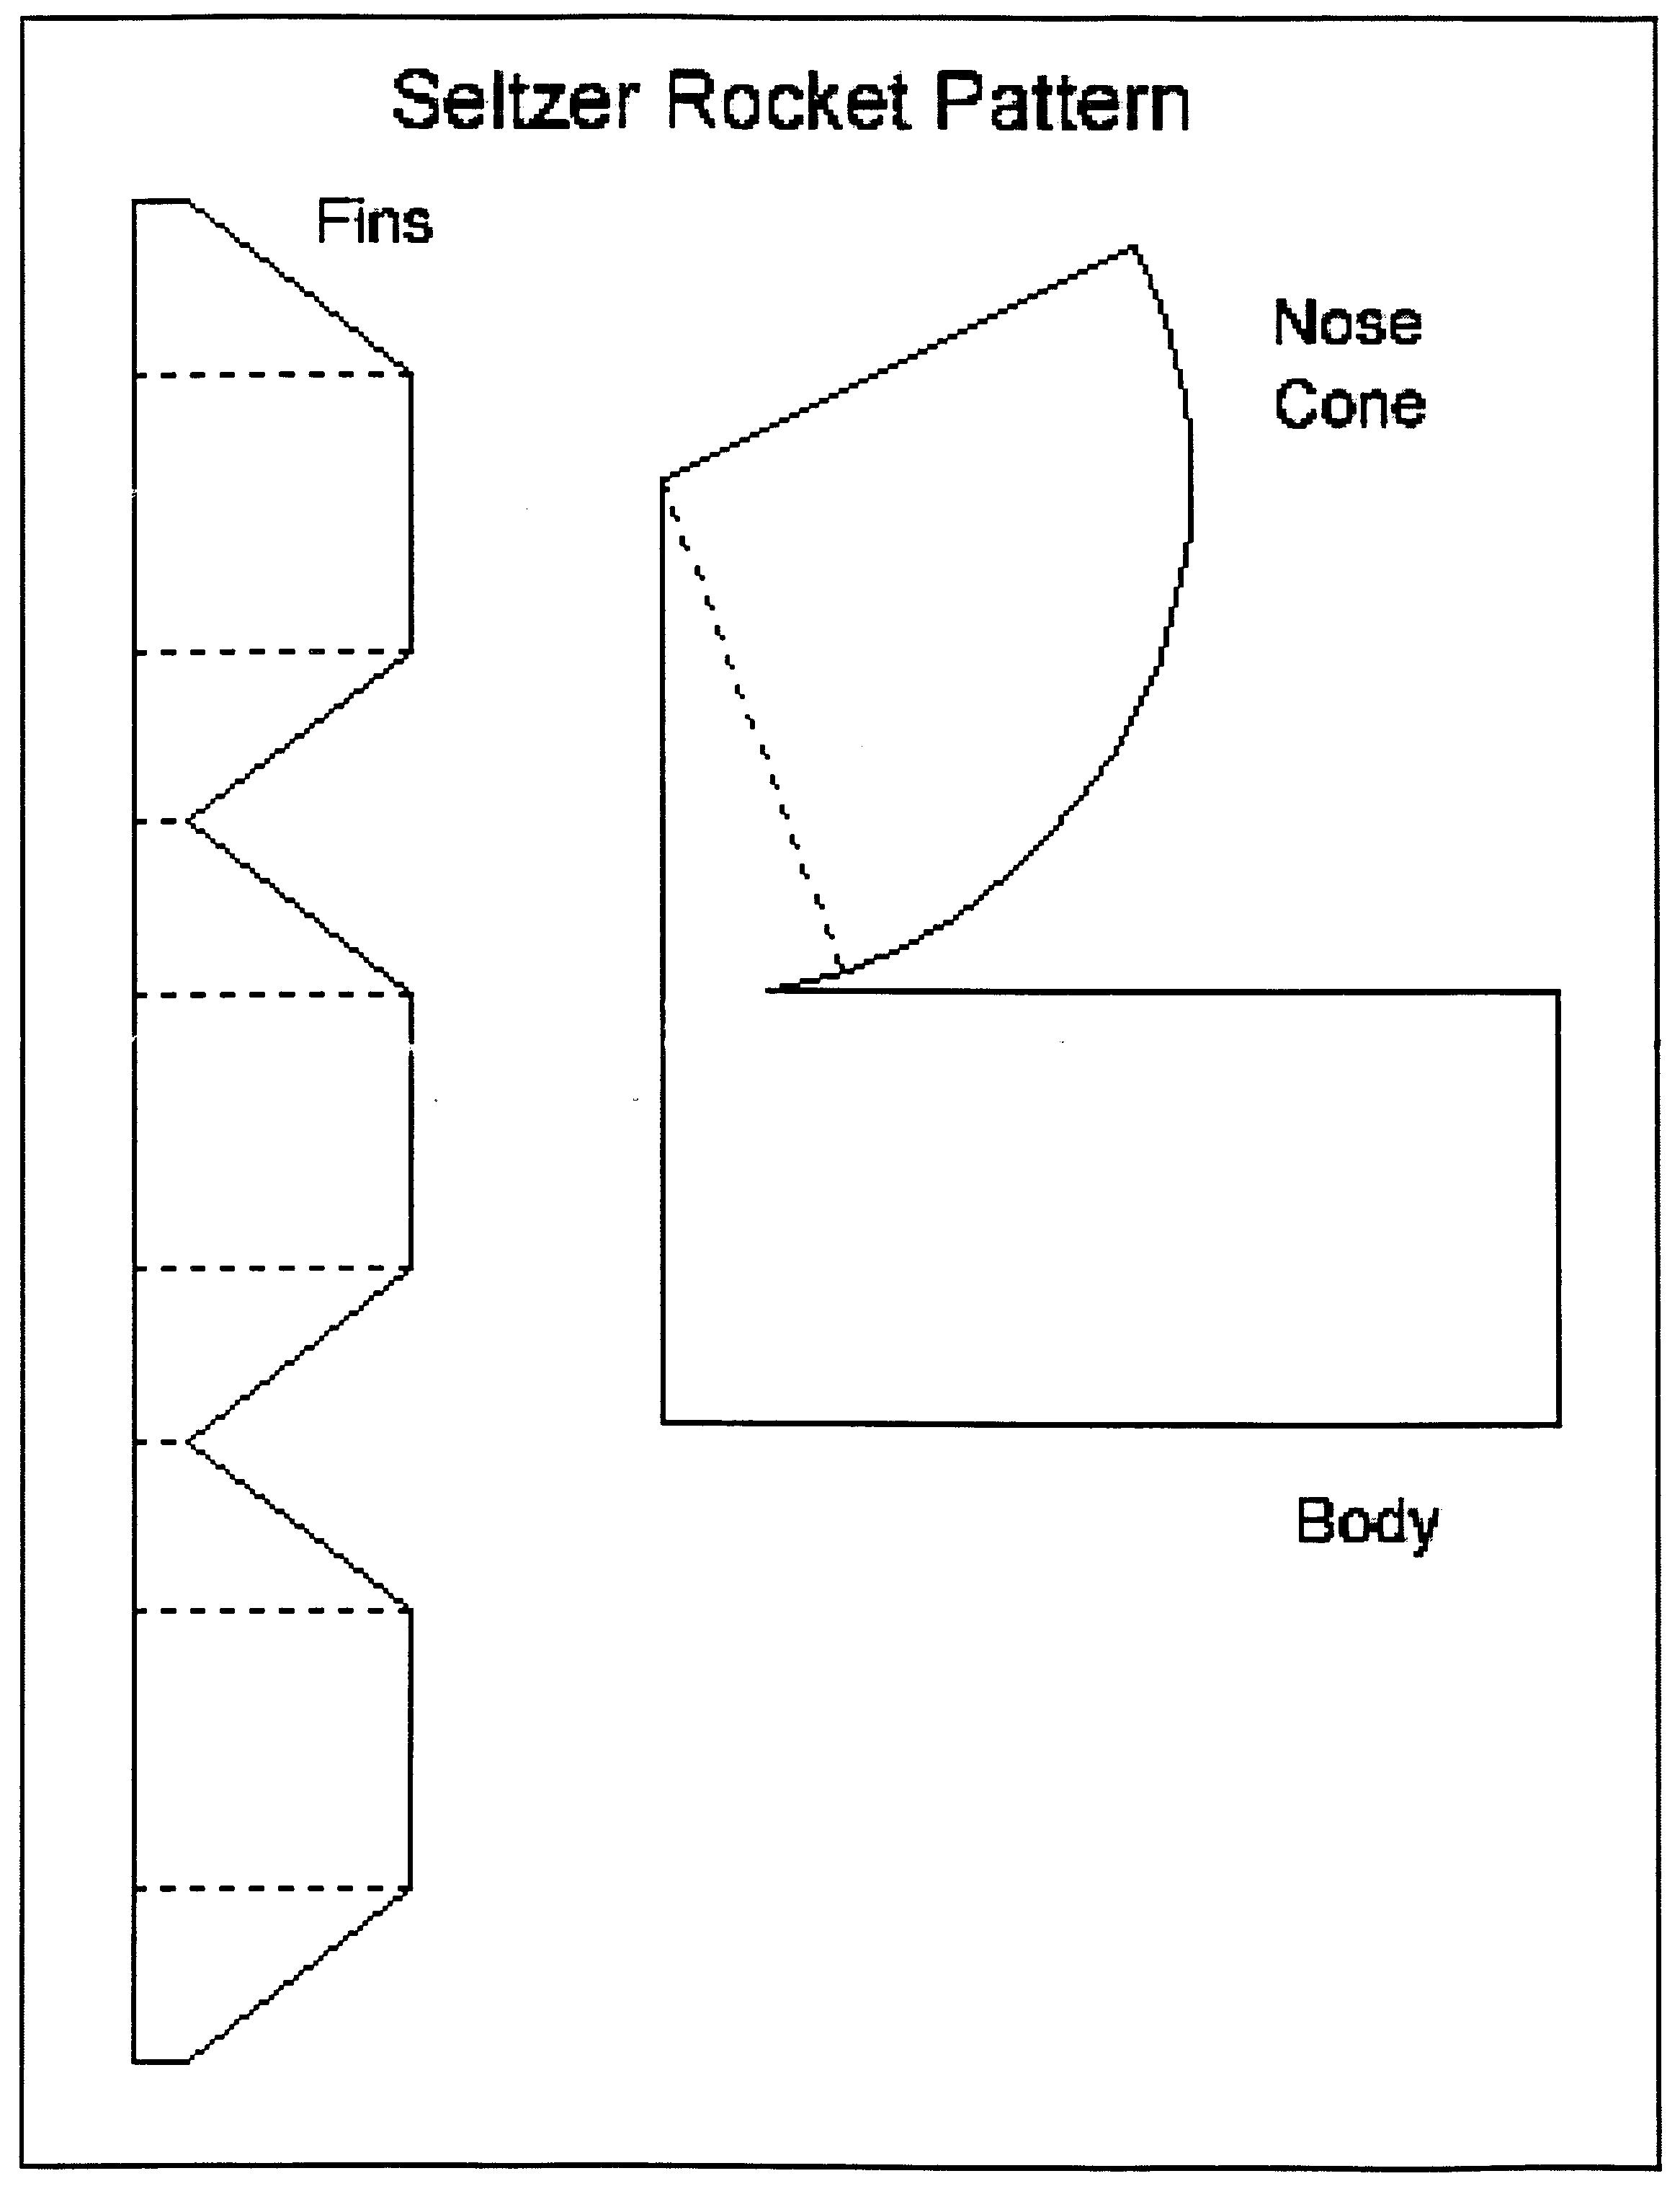
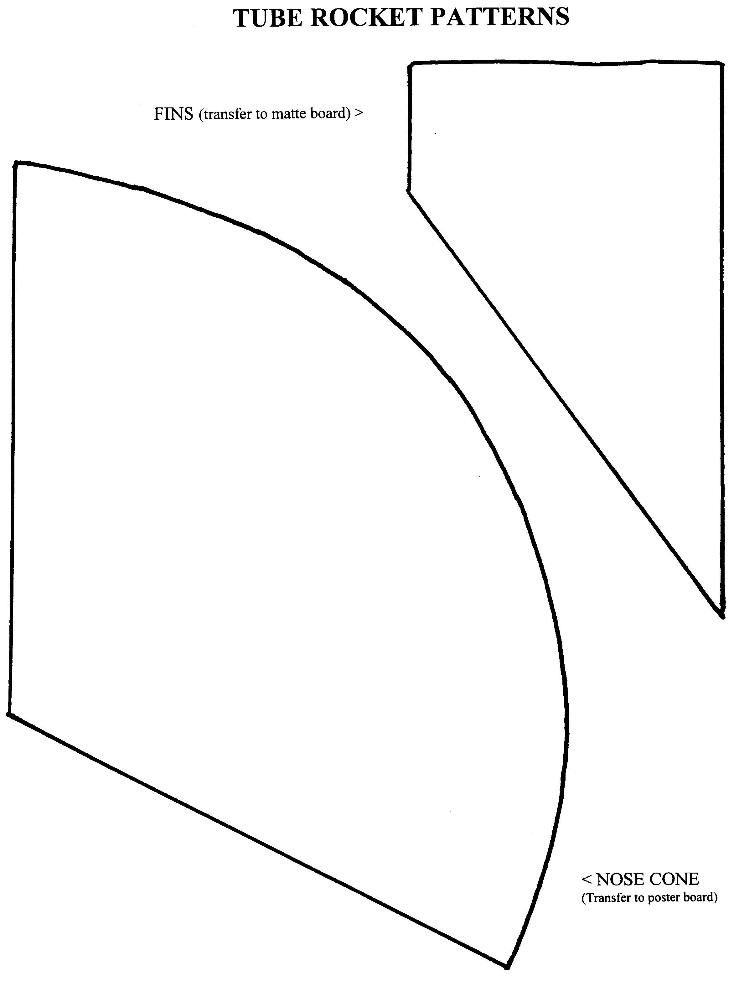
Santa Clara County Council Boy Scouts of America

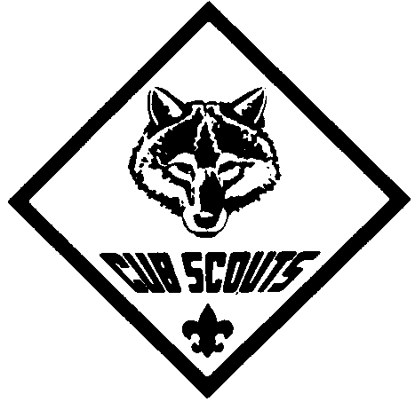
Cub Scout
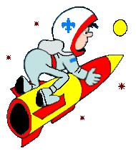

Saturday, April 23, 2005
12:30 - 5:00 PM
Rainbow Park, San Jose
(Johnson & Rainbow, Across from Lynbrook H.S.)

WHO: This event is open to all registered Cub Scouts (Tiger Cubs to Webelos) in the Santa Clara County council. Sponsored by Pioneer district.

WHAT: Come and enjoy the fun and excitement of building and launching soda bottle rockets. We will supply the rocket kits and materials on the day of the event. The boys will build the rockets, then launch them with water and compressed air.

COST: Only $5 per scout, which includes a rocket kit and patch. All registrations must be returned by April 16, 2005. No late registrations or drop-ins accepted. Register early to reserve spot – Space Limited – Event sold out last year.

AWARDS: Medals will be awarded to the top 3 winners for
SCHEDULE: 12:30 - 2:00 pm Check-in, and Rocket Construction
2:20 - 2:30 pm Opening Ceremony
2:30 - 3:00 pm Tigers
3:00 - 3:30 pm Wolf
3:30 - 4:00 pm Bears
4:00 - 4:30 pm Webelos
4:45 - 5:00 pm Awards & Closing
each Cub rank. Winners are determined by flight
time from 2 launches. Ribbons will be awarded for
participation.

CONTACT: For more information, please contact
Wesley Wong, at 408-377-2859 or
e-mail at wesley.wong@sbcglobal.net



CUB SCOUT 2005 WATER ROCKET DERBY REGISTRATION Forms Due by: April 16, 2005
Saturday April 23, 2005 – Rainbow Park

Name: ___________________________________ Grade: ________ Pack: _________ □ Tiger □ Wolf □ Bear □ Webelos

Name: ___________________________________ Grade: ________ Pack: _________ □ Tiger □ Wolf □ Bear □ Webelos

Parent: ______________________________ Phone: _____________ Amount Attached: $5.00 X _____ = _____________
#Boys Total

MAIL REGISTRATION TO:
PLEASE MAKE CHECKS PAYABLE TO:
BSA - SCCC
(Write on check: Event Code # 303)
Santa Clara County Council, Boy Scouts of America
Cub Scout Water Rocket Derby, Event Code # 303
970 W. Julian St.
San Jose, CA. 95126

