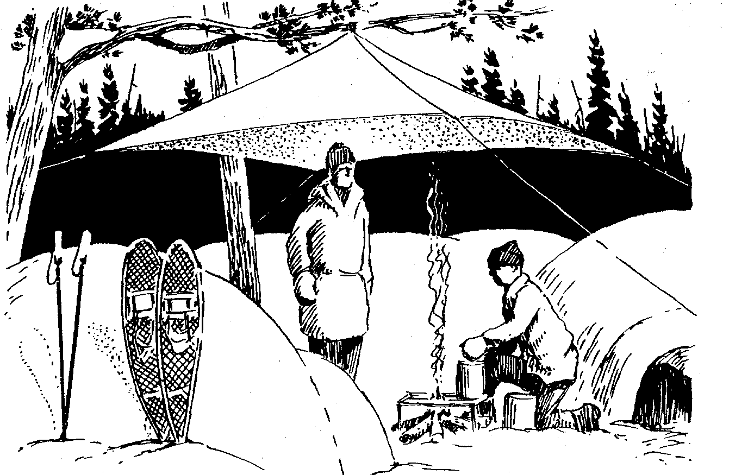
Snow Camping

Presented by the

George Denise, Chairman, Bear Paw 2005-6

gdenise@adobe.com

High Adventure Team of the

Santa Clara County Council
Boy Scouts of America

How To Dress For Snow Camping

When you are at a ski resort or mountain cabin with your family, you can play outside in the snow, and when you get too wet or too cold, you can come inside, change your wet clothes and warm up by the heater or fire. In cold weather camping, there is no inside other than the inside of your tent or snow cave. You have a limited number of changes of clothes, and taking off wet clothes in the tent has a tendency to get everything else wet. At night, the wet clothes you took off will freeze, making them that much more difficult to deal with.

In Wilderness, It Is Far Easier To Stay Warm To Begin With, Then To Try To Get Yourself Warm Again After Becoming Cold

Conserve Body Heat

The goal in cold weather camping, then, is not to keep cold out; it is to keep your own body heat in.

Maintain Thermal Equilibrium

The goal also is not to make yourself as warm as possible; rather it is too maintain “thermal equilibrium.” You do not want to become too cold, nor do you want to become too hot, overheat, and begin to perspire. Perspiring will cause your clothing to absorb moisture, which helps it conduct heat away from your body faster, and the process of perspiration evaporating also lowers your body temperature. This will make you too cold later when you become less active and the outside temperatures begin to drop once the sun goes down.

Protect the Head and Trunk (the Body Core)
While we do not want to leave any area unprotected, we are expecially concerned with protecting the head and trunk. When the body core is warm, blood circulates out to the extremities much better, warming them too. If the core is cool, it is very difficult to warm it externally short of immersion in a hot bath. Keeping the core warm with dry, insulating clothing, warm, high-energy foods and liquids, and a combination of exercising with adequate rest works best.

Strive for Versatility

Your wardrobe should be versatile, allowing you to adjust it and adapt it to a variety of conditions over the course of the day and night. The following illustration shows layering using traditional clothing fabrics:

Layering

The best way to achieve this versatility is through the use of layers of clothing.

Layers include:

- Long underwear – ideally made of polyester, polypropylene, wool-poly blend, silk, or a wool-cotton blend (not the best)

- Insulating layer – synthetic fiber pile, wool, or wool blend is best

- Outer shell – Gore-tex and it’s clones are best, as they allow water vapor to escape, while keeping rain and melted snow out. This should be a wind breaker/water repellant layer with a hood.

- Rain suit or poncho - to keep out heavy snow and rain

- Accessories – sunglasses or ski goggles, wool or polyester “beanie”, or balaclava (covers face too, with opening for eyes, nose and mouth), polyester glove liners and insulated gloves with water repellant shell, polyester sock liners with polyester-nylon-wool blend insulated socks, rubberized, insulated leather boots, or rubber galoshes.
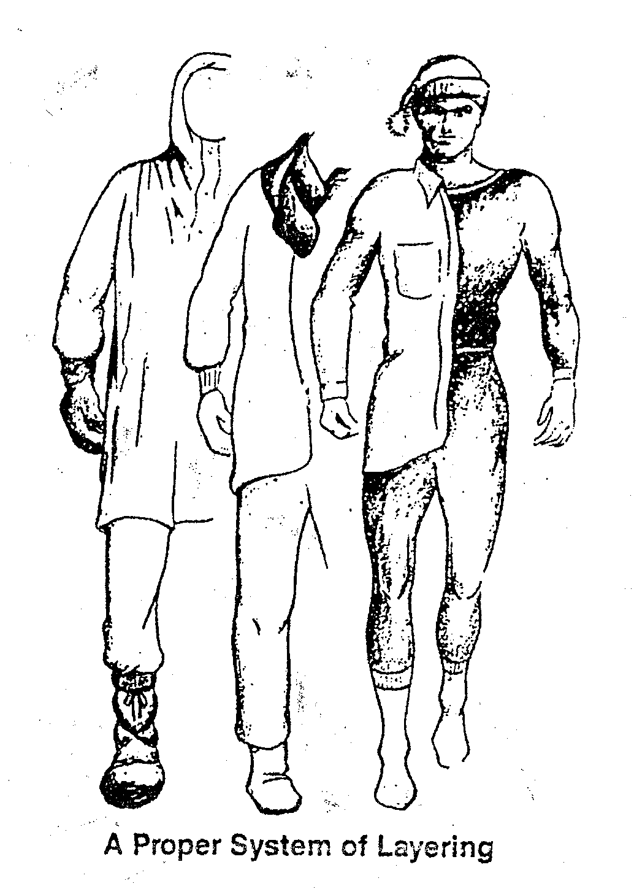

Synthetic materials, such as polypropylene and polyester have a very low water absorption factor. Polypropylene, for example, absorbs less than .1% of its weight in water. Instead, it wicks moisture away from your body to the outer layers, where it is either absorbed or wicked still further, depending on the make-up of that material. This is important, because we lose body heat much more rapidly through water than we do through air.

Fiber Piles
Fiber pile is mostly polyester. Polyester is a very stiff, springy fiber that holds its loft for trapping air. Pile begins as a thin, dense cloth which is then passed through napping machines until a thick pile, commonly called fleece, is achieved. Polyester wicks almost as efficiently as polypropylene. You can dip it in water, wring it out, and it will still retain its loft and keep you reasonably warm. Pile clothing is generally rated as 100 (light), 200 (medium), and 300 (heavy weight).

Wool
Wool and wool blends absorb moisture, but they also retain much of their loft and therefore insulating ability when wet.

Cotton
Cotton is probably the least desirable material for winter camping/snow play, because it absorbs water readily and when wet loses virtually all of its insulating ability.

Down
Down is a very good insulator as long as it is dry. It maintains greater loft for a given weight than any other materials, as long as it is dry. It mats down when wet, however, and loses almost all of its insulating ability.

Gore-tex
Gore-tex, along with a few recent clones, is essentially a thin, flexible Teflon membrane laminated between two layers of nylon cloth. This membrane contains 9 billion pores per square inch. Each pore is 20,000 times smaller than a drop of water, but 200 times larger than a molecule of water. It can still leak, especially in driving rains, and it needs to be close to the skin so that it does not get too cool and condense the water vapor moving up from the body and trap body moisture inside the shell.

What and How To Pack for Snow Camping

Take Everything You Might Need, - in the Lightest Weight Possible

No More Than 25% - 30% of Body Weight

Internal Frame Backpack

Four-Season Tent

Ground Cloth

Sleeping Pad – Ensolite or Therm-a-Rest

Sleeping Bag; Rated to 0 Degrees, Synthetic

Pack Everything In Zip-lock Bags

Extra Clothing

Rain Suit or Poncho

Backpacking Stove With Fuel

Cooking Utensils

Pocket Knife

Two Quarts of Drinking Water

Personal First Aid Kit

Matches, Fire Starter, Candles

Flachlight or Headlamp With Extra Batteries, Bulbs

Personal Toiletries Kit

Compass, Map of Area

6 Extra 30 Gallon Trash Bags

Toilet Paper

Small Plastic Shovel or Snow Shovel

What and How To Pack for Snow Camping

When packing for snow camping, the goal, as with packing for summer camping, is to be sure you have everything you will need, but no more than that, and in the lightest means possible. Generally, you do not want to be carrying more than about 25% to 30% of your weight. If you weigh 100 pounds, your pack should weigh no more than 30 pounds. Our goal in winter camping is to stay warm and dry. To do this, we need to pack all the right stuff, and only the right stuff.

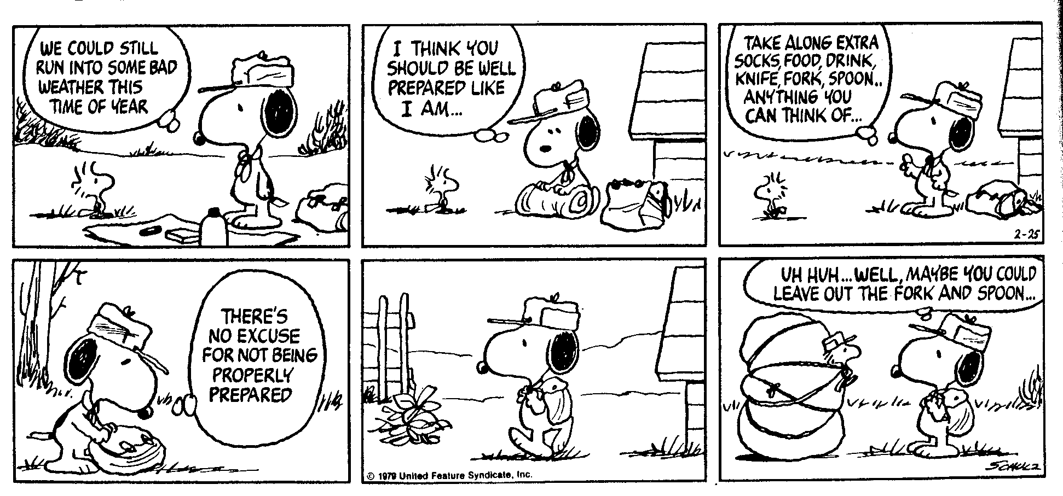

Backpacks

External and internal frame packs.

External frame packs were designed to carry weight on the hips. This weight is deliberately placed high so that the center of gravity of the pack is at least shoulder level. This high placement of the center of gravity minimizes the backward pull of the frame and allows the weight to be balanced on the pelvic girdle (which is a cone of bone – not muscle – and the strongest part of your body). This external system is designed for hiking primarily on trails. The very thing that makes it so very efficient – the external frame itself – makes it less than ideal for other aspects of backpacking, namely climbing, steep off-trail work, or cross country skiing or snow shoeing.

With an internal frame pack, the center of gravity is placed much lower for better control and balance. Because much of the weight is carried over the shoulders these packs have extensive adjustability in shoulder and hip area. This isn’t as important in an external frame pack.

Modern-style backpacks have become so well-designed, a good internal-frame pack will serve most of your needs.

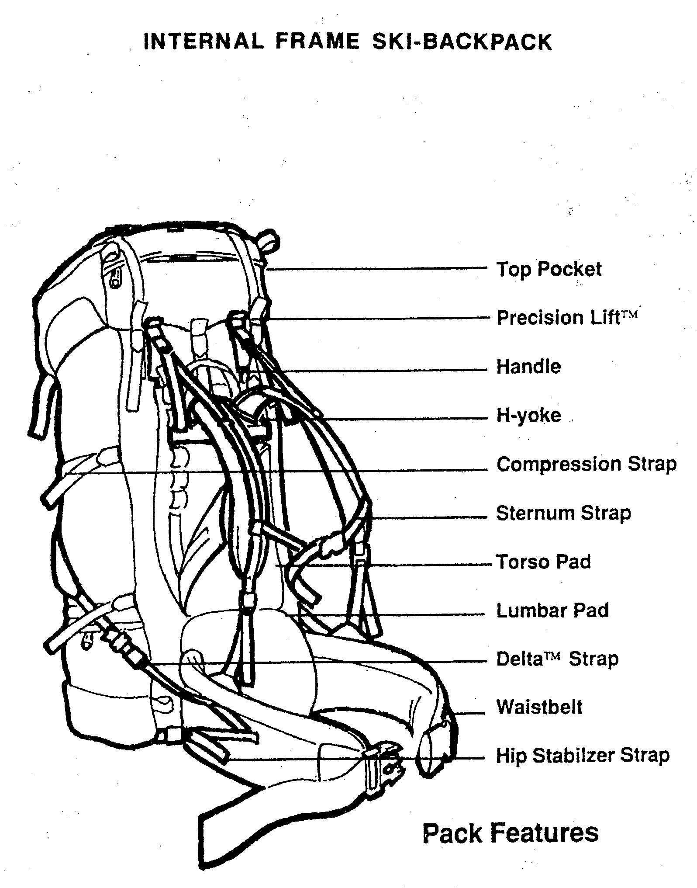

Sleeping Bags

Before you purchase a sleeping bag for cold weather camping, examine your needs and select one of the following categories. Then check the fills of bags in that category. Finally, check the construction features of the bags available.

Sleeping Bag Categories

The camping bag is designed to be carried in a car. It is usually designed more for comfort than for thermal efficiency. The bag is most often rectangular, heavy or bulky, and not easily compressed. It can be used in temperatures above 32 degrees Fahrenheit.
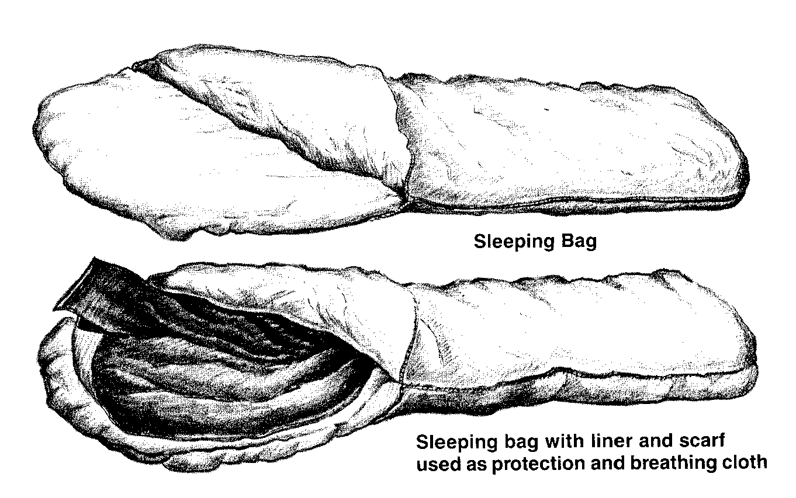
The backpacking bag is designed to fit in a backpack. This bag is usually a modified mummy bag, a thermally efficient shape. The fill is typically made of fibers that are compressible yet resilient. The bag should weigh less than 5 pounds and have a temperature comfort rating of 30 degrees Fahrenheit or lower.

The winter expedition bag should have a temperature comfort rating of 0 degrees Fahrenheit or lower. It must fit on a pack frame, and be of the highest quality due to the often life-threatening situations of its use. This bag will be heavier, perhaps six or seven pounds; to increase warmth we much increase weight.

Fills

There are many fills for sleeping bags, ranging from wool batts, to many types of polyester, to goose down. The fill has a great deal to do with the size and warmth of the bag. When investigating sleeping bags in a store, be sure to check on whether the fill will shift during use, making cold spots in the bag. The amount of loft is also important. It indicates the insulation factor.

What happens if our sleeping bag gets wet? If your bag is completely soaked, it will lose insulation and be wet for hours. Even a synthetic bag will lose about 10 percent of its warmth, gain 128 percent in weight, and take more than a day to dry. A down bag becomes useless. This becomes a major concern if you plan to use your bag in wet or humid conditions.

Carry your bag in a waterproof sack and sleep in a waterproof tent to minimize wetness problems.

Construction

Check out the construction of the bags. The interior construction is hard to check except by asking questions at the store. External construction is easier to examine. Here are a few things to check for:

- Start with the stitching. If you can snag it with your fingernails, it’s suspect.

- The shell should be of a fabric that does not allow the insulation to filter through. Uncoated fabrics are best so that body moisture can easily pass through.

- Turn the bags inside out to see how they are finished. In better bags, inside seams are stitched to seal fabric edges.

- Check the diameter and length of the draft tube. It should be longer and larger than the zipper it is covering.

- Check for zipper stiffener, a webbing strip running the length of the zipper to prevent snagging.

- Take off your shoes and climb into the bag. It should be cut generously enough to allow elbows, shoulders, knees, and feet to move without compressing the loft. Though you need to move, you don’t want too much room. Excess room increases air flow and reduces the bag’s thermal efficiency.

- Draw the hood closed to make sure that the air hole is near your mouth.
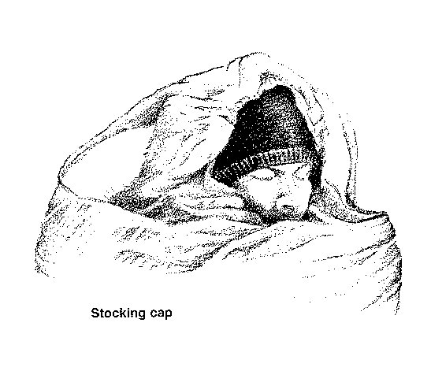

Do You Have Trouble Keeping Warm?

Your body metabolism affects how warm or cold you are when you sleep. Physically fit people and those with more muscle tend to sleep warmer, but anyone can improve their comfort and warmth while sleeping by remembering the following tips:

- Sleep on a pad. Sleeping pads provide insulation and comfort. Air mattresses, while soft and comfortable, offer virtually no insulation.

- Drink plenty of water, even in cold weather. Dehydration from lack of liquids results in poor circulation to the extremities, causing them to become cold or even to freeze.

- Eat before you go to bed. Hot foods are especially helpful.

- Go to bed warm. Exercise to raise your body heat before sleeping.

- Wear a sock hat or fleece hat to bed to control heat loss from the head and neck area.

- Wear dry clothing for sleeping, and the more the better, up to the point where you’re constricted. Waterproof clothing adds lots of warmth, but will cause some condensation of perspiration.

- Use tents, shelters, or sleeping bag covers to get out of the wind. Wind reduces the insulation effectiveness of sleeping bags just as it does with clothing.

- Place a bottle of hot water in your bag.

- Sleep close to another person.

- Sleep on your side in a fetal position, with extra clothing under your shoulder and hip.

- Buy a warmer bag than you think you will need.

- Take your two Siberian huskies into your tent with you!

Keep your sleeping bag dry. While a synthetic bag only loses about 10% of its insulation ability if it gets wet, a down bag loses most of its ability to insulate (keep you warm). Sleeping bags become wet from outside moisture, from sweating on the inside of the bag, and from water vapor escaping from the mouth or nose into the bag.

To keep outside moisture from wetting the bag, place protective insulating material, such as a closed-cell foam pad, or a Therm-a-rest type sleeping pad (insulated air mattress) under it. Better still, use two closed-cell pads together, or one closed-cell foam pad and a Therm-a-rest type pad together.

Avoid sweating by wearing the least amount of clothing necessary inside the bag to keep warm and by using the proper sleeping bag for temperature conditions.

Try not to breath into the bag; if you do, moisture will collect and wet the bag or form ice crystals. If your face gets too cold, cover it with a towel or muffler.

When not in use, open the bag wide so that fresh air can get into it. Turn it inside out and hang it over the top of the tent, or on bushes or low hanging tree branches so that sun and wind can help dry it. Always shake the bag out and fluff it up when arising.

Here are two tips that will help you keep warm in your sleeping bag and let you get a good sleep:

- Eat a little something just before you crawl into the bag. This can be a candy bar, energy or power bar, energy drink, hot chocolate, etc. This gives your body a little energy and lets you sleep warmer.

- Always relieve yourself just before you go to bed. The act of getting out of a warm sleeping bag in the middle of the night to go outside can be
a chilling experience!

