2005 Pioneer District Trail to First Class Skills Weekend

Preparing our scouts for Advancement and Adventure

Dear Unit Leaders,
This manual is designed to inform you of our plans to help your scout attain the skills they may not have in working towards the rank of First Class. This should help you prepare your scouts and units for a weekend of learning, fun and friendship. Please read this manual in its entirety.

Mark your calendar for the weekend of November 11th, 12th, and 13th of 2005.

Yours in Service and Scouting,
Pioneer TtoFC Staff

Contents
Event Overview 1
Order of the Arrow 1
General Rules 1
Event Organization and Rules 1
Scout’s Booklets 1
Skills Areas 1
Tour Permit 2
Schedule 2
Friday, November 11th 2
Saturday, November 12th 2
Sunday, November 13th 2
Check In 3
Boy Scout Training Areas and Descriptions 4
Activities for Scouts not in skills training 6
SPL/Adult Leader Meeting 6
Open Fires 7
First Aid 7
Warnings! 7
Poison Oak 7
Knives and Axes 7
Lanterns and Stoves 7
Cooking 7
Water 8
Sanitary Facilities 8
Trash and Garbage 8
Tents 8
Taps 8
Campfire Skits, Songs, and Walk-Ons 8
Scouts Own 9
Uniforms 9
Flags 9
Lost and Found 9
Equipment Checklist 9
Forbidden Items 9
Webelos Scouts 10
Cooking Menu Submissions 10
Text Directions to Chesebrough 10
Map Directions to Chesebrough 11
Map of Chesebrough 12

Event Overview
This weekend is designed to give opportunities for scouts to earn skills and work on advancements that they may not have the chance to work on throughout the year. There will be seven areas open, but the scout participating will need to choose 4 areas to work on. The scouts will be given time schedules for each individual request. We will do our best to make this a weekend to remember for all.

Order of the Arrow
Scouts in the Order of the Arrow will be your camp staff. The O.A. can be depended on to solve many of your camp issues and directions, rely on them.

General Rules
The Scout Law, Scout Oath, and the Outdoor Code are the guiding rules of enforcement. Please respect nature here at Chesebrough; it belongs to everyone.

Event Organization and Rules
This weekend is geared to helping the younger scouts work on outdoor activities they may not have had the chance to work on earlier in the year. Although this may seem like an individual based weekend, it will require the teamwork and support of all in attendance. You will be bringing your own food and cooking in your own campsite areas. Please come prepared with proper food storage containers (coolers are ok but there are squirrels). You will also need to bring your own clean up supplies for your area.

Scout’s Booklets
Booklets we will hand out are guides that will help the individual scout keep track of what they worked on this weekend. Please have scouts write their names on them as soon as they get them.

Skills Areas
Our seven skills areas are set up to offer diversity in providing needs for the scouts. The scouts will only be able to attend four sessions on Saturday. These sessions will be planned for one hour and fifteen minutes, allowing fifteen minutes for sign-off and walking to the next session. Scouts will be expected to sign up for the areas they need before coming on the weekend event. We will try to accommodate all reasonable requests for activities. We are interested in making this a regular event that enriches the scout spirit and provides opportunity.

Tour Permit
Download the Tour Permit using this link http://www.scouting.org/forms/34426.pdf

Schedule

Friday, November 11th
4:00 PM - Registration and Check-In Opens
9:00 PM - Registration Closes
9:00 PM - SPL and adult leader meeting and cracker barrel
11:00 PM - Taps (all quiet in camp)

Saturday, November 12th
6:00 AM - Reveille
8:00 AM - Finish Breakfast
8:30 AM - Morning Colors and Opening Ceremony
9:00 AM - First Session Begins
10:30 AM - Second Session Begins
12:00 PM - Lunch Break
1:00 PM - Third Session Begins
2:30 PM - Fourth Session Begins
4:00 PM - Fourth Session Closes
4:30 PM - Evening Colors
5:00 PM - Dinner Preparations and Eating
7:00 PM - Dutch Oven Competition ends
8:00 PM - Campfire
11:00 PM - Taps (all quiet in camp)

Sunday, November 13th
6:00 AM - Reveille
8:30 AM - Finish Breakfast
9:00 AM - Scouts Own
10:00 AM - Clean Campsite and Check-Out
11:30 AM - Leave Camp

Check In
Units may check in from 4:00 to 9:00 on Friday evening. All training classes and campfire will be held on Saturday. Check-out will be on Sunday morning following scouts own. The road will be temporarily closed during this time, and no exit will be possible until its completion.
Your troop will be responsible for bringing food for your scouts and leaders. Please plan to bring your own cooking and clean up supplies. The only food we will be providing is the cracker barrel on Friday night for leaders.
This is a chance to join in one of the oldest traditions of Boy Scout History. The Skills Weekend is a chance to work on Scout skills in an outdoor environment while camping. There will be fun, friendship, and learning to do.
This guide will help you prepare your troop and youth for the first annual Trail to First Class Skills Weekend. Registration will be done by email. Look for the link on the Pioneer District home page. This link will allow you to fill out the form and it will send an email in for registration. The cost is just $10 per person (adult and youth), which includes patches, cracker barrel for leaders, program materials, and insurance. Please pay at check out, or during the weekend. There are a limited number of spots available, so do not register boys or adults that will not be attending.
Each of the skills areas will be run by a troop organization. Our goal is to provide more opportunities for the O.A. to assist the district with camping skills and planning. Please do not hesitate to ask for help. These scouts need the opportunity to lead. We expect the troop that runs a particular training skill to be efficient and thorough in the materials they present to our young scouts. The organizing troop will provide enough staff, primarily of Older Scouts, to instruct the youth at this event. If you do not have enough boys to staff your area, we should be able to fill in your staffing with boys from other troops. All material will be presented in accordance with the current Boy Scout Handbook.
We will not be signing in Scout’s Handbooks at this event; unless a member of the troop participating does it for one of their members. We will be providing a booklet that will describe all the planned activities, and once they have completed a particular skill at their session can be marked off in this booklet.
In the event of an emergency that endangers the camp, we blow a marine foghorn three times to signal the camp. Upon hearing this, you should drop everything immediately and gather your unit. You should arrive at the Pole Barn to be accounted for. Please walk and keep a cool head. If you hear the emergency signal, you need to assume it is a real emergency.

Boy Scout Training Areas and Descriptions
Compass: Will meet at the Pole Barn and embark from there.
S1a. Demonstrate how a compass works and how to orient a map. Explain what map symbols mean.
F1 Demonstrate how to find directions during the day and at night without using a compass.
F2 Using a compass, complete an orienteering course that covers at least one mile and requires measuring the height and/or width of designated items (tree, tower, canyon, ditch, etc.).
Knots: Will meet at the field in front of the Pole Barn.
T4a. Demonstrate how to whip and fuse the ends of a rope.
T4b. Demonstrate that you know how to tie the following knots and tell what their uses are: two half hitches and the taut line hitch.
F7a. Discuss when you should and should not use lashings.
F7b. Demonstrate tying the timber hitch and clove hitch and their use in square, shear, and diagonal lashings by joining two or more poles or staves together.
F7c. Use lashings to make a useful camp gadget.
F8a. Demonstrate tying the bowline knot and describe several ways it can be used.
First Aid: Will meet at the Pole Barn table area.
T12a. Demonstrate the Heimlich maneuver and tell when it is used.
T12b. Show first aid for the following: Simple cuts and scratches, Blisters on the hand and foot, Minor burns or scalds (first degree), Bites or stings of insects and ticks, Poisonous snake bites, Nosebleed, Frostbite and sunburn.
S6a. Show what to do for “hurry” cases of stopped breathing, serious bleeding, and internal poisoning.
F8b. Demonstrate bandages for a sprained ankle and for injuries to the head, upper arm, and the collarbone.
F8c. Show how to transport by yourself, and with one other a person from a smoke-filled room, and a person with a sprained ankle (for at least 25 yards).
F8d. Tell the five most common signs of a heart attack. Explain the steps (procedures) in cardiopulmonary resuscitation (CPR).
Outdoor Identification: Will meet at the Nature Walk area below the parking lot.
T11. Identify local poisonous plants; tell how to treat for exposure to them.
S5. Identify or show evidence of at least ten kinds of wild animals (birds, mammals, reptiles, fish, mollusks) found in your community.
F6. Identify or show evidence of at least ten kinds of native plants in your community.
Camping: Your campground area.
T2. Spend at least one night on a patrol or troop campout. Sleep in a tent that you have helped pitch. This is probably the easiest requirement to do this weekend… almost a freebie for attendees.
Cooking: Will meet in the lower barbeque area.
T3. On one campout, assist in preparing and cooking one of your patrol’s meals. Tell why it is important for each member to share n meal preparation and cleanup, and explain the importance of eating together.
F4a. Help plan a patrol menu for one campout—including one breakfast, one lunch, and one dinner—that requires cooking. Tell how the menu includes the four basic food groups and meets nutritional needs.
F4b. Using the menu planned in requirement 4a, make a list showing the cost and food amounts needed to feed three or more boys and secure the ingredients.
F4c. Tell which pans, utensils, and other gear will be needed to cook and serve these meals.
F4d. Explain the procedures to follow in the safe handling and storage of fresh meats, dairy products, eggs, vegetables, and other perishable food products. Tell how to properly dispose of camp garbage, cans, plastic containers, and other rubbish.
F4e. On one campout, serve as your patrol’s cook. Supervise your assistant(s) in using a stove or building a cooking fire. Prepare the breakfast, lunch, and dinner planned in requirement 4a. Lead your patrol in saying grace at the meals and supervise cleanup.
Tot’n Chip: Will meet in the upper campground area.
S2c. On one campout, demonstrate proper care, sharpening, and use of the knife, saw and ax, and describe when they should be used.
Fireman Chit: Will meet in the upper campground area.
S2d. Use the tools listed in 2c to prepare tinder, kindling, and fuel for a cooking fire.
S2e. Discuss when it is appropriate to use a cooking fire and a lightweight stove. Discuss the safety procedures for using both.
S2f. Demonstrate how to light a fire, and a lightweight stove.
Flags & Ceremony: Meet in the Flagpole area
S3. Participate in a flag ceremony for your school, religious institution, chartered organization, community, or troop activity.
F4e. Saying Grace with your troop or patrol
Scouts Own, participate on Sunday
Honor in wearing your uniform.

Activities for Scouts not in skills training
Monkey Bridge in the flag pole area. Scouts will be able to participate in building a bridge by tying knots and making the bridge.
Scavenger Hunt will be run throughout the camp. Information must be gathered from the site and participating staff members. This will encourage communication, and interaction while exploring the whole camp. The scout with the best score will be announced at campfire.
Skits for Campfire will be planned with the O.A.; they will be holding a workshop on how to plan and run a campfire program. Scouts are encouraged to learn what to do, and share what they have learned at Saturday night’s campfire

SPL/Adult Leader Meeting
Friday night will be mandatory TtoFC Leadership meeting at 9:00 in the Pole Barn area. All SPL’s and adult leaders should be at the meeting. The unit leaders will get their booklets to distribute to the scouts for Saturday’s events.
This meeting will also be used to answer any questions, resolve issues, and make any changes or last minute additions to the program. We will be asking for volunteer service patrols to help clean the camp before we leave for the weekend. After the meeting, we will have a cracker barrel. Saturday evening, after the campfire, adult leaders are welcomed to share helpful comments and suggestions with the staff at the camp headquarters.

Open Fires
Fire will only be permitted in the campfire rings provided. Firewood will not be provided, so troops are encouraged to bring their own wood, kindling and tinder. The fires will need to be under an adult supervision at all times. Each unit must follow fire safety rules and are responsible for providing their own safety equipment (water bucket, shovels, etc.).

First Aid
First aid treatment is available at the office attached to the kitchen building (on the other side). There will be qualified personnel roaming the events on Saturday. Many of the staff will have fsr’s (family service radios) and can contact the first aid person in an emergency. All injuries and illnesses must be reported to the first aid station; no matter how minor they appear, as they must be entered into the first aid log.

Warnings!

Poison Oak
Poison Oak is all around us here at Chesebrough. All scouts should be able to identify poison oak. It is especially important that you DO NOT burn poison oak. Any Scout who gets into poison oak should follow normal procedures of washing immediately with soap and water.

Knives and Axes
No sheath knives are allowed! Boy Scouts may use axes only if an ax yard is set up and marked off by the troop.

Lanterns and Stoves
Scouts may use liquid fueled lanterns and stoves, but both must be under the supervision of an adult. No lamps, candles or other heat or flame sources are allowed in tents.

Cooking
Boy Scouts do their own cooking by the patrol method. Scouts who are working on requirements for cooking should submit their meal plan for approval before this weekend. Since we are not signing in books, the meal approval should be done before they buy their food and come to camp. The scouts should be looking for meals that they can prepare themselves on an open flame or cooking stove to satisfy the requirements. The scouts should be planning their meals just as they would no a normal campout. It is up to the individual units to bring their own cooking stoves, pots and pans, utensils or other cooking equipment. All units will cook at their own campsites.
It is strongly suggested that the time constraints of the TtoFC weekend be kept in mind when planning your meals. Time for cooking and cleaning will be at a minimum for the sake of the number of activities that will take place.

Water
Water is available, but each unit is required to bring water containers and facilities for washing. You will be required to transport water from the faucets to your area. Wash dishes in your campsite, not at the restrooms!

Sanitary Facilities
A SCOUT IS CLEAN. Restrooms are available in 4 places throughout the camp. Please use them for their intended purposes. Do not use trees, and do not dig latrines n your campsite. Please keep these facilities clean, as several people in the course of the weekend will use them. It is required for each unit to bring 1 roll of toilet paper of each 4 people in your unit. The campmaster may request you to donate a roll toward the use on one of the facilities. Showers are at the restrooms near the pole barn, a schedule will be posted for usage if you will be taking a shower.

Trash and Garbage
Pack it in- pack it out! Please bring seal-able garbage bags for disposal of your trash and garbage. Everyone must haul out their own trash and garbage on Sunday. Please remember that animals live in the camp too, keep food put away when not cooking. The dumpster is past the parking lot; look for the location on the map.

Tents
Remember low impact camping techniques. Tent ditching or trenching is not allowed. Look for a well-drained area to pitch your tent.

Taps
A SCOUT IS COUTEOUS. After taps every Scout is expected to be in his tent and quiet at that time. If you must move about in your own area after taps, do it quietly so that others are not disturbed. Roaming about the campgrounds or other campsites will not be tolerated.

Campfire Skits, Songs, and Walk-Ons
All units are expected to participate in Saturday night’s campfire. Please Be Prepared to present your entry in front of the camps staff prior to the campfire. The appropriateness of the skit, song, or walk-on is the final judgment of the staff.

Scouts Own
A SCOUT IS REVERENT. We will have a non-denominational Scout’s Own for all Scouts and leaders on Sunday morning (see schedule). We request everyone to attend this function as no other activities will be planned or allowed during this time. NO VEHICLES WILL BE LOADED OR MOVED DURING THE SCOUT’S OWN.

Uniforms
All Scouts and leaders must wear uniforms while traveling to Chesebrough, and for check-in and checkout. Second class, or troop activity uniforms will be permitted while participating in the program classes, but full uniform is required for Saturday night’s campfire and Sunday morning’s Scout’s Own.

Flags
All Scouts and leaders are expected to attend opening flags on Saturday morning in the flag meadow, please see your map if you do not know where this is. Closing flags will be Saturday afternoon. Units may display their troop or patrol flags in their campground areas.

Lost and Found
A SCOUT IS TRUSTWORTHY. Please see someone in the office if you have lost anything. The office is located in the same building as the kitchen and first aid.

Equipment Checklist
The equipment needed for a good Trail to First Class Skills Weekend is the same as that which is needed for a normal campout. The Boy Scout Handbook has a simplified list of minimum equipment. Do not forget the 10 essentials. Please be prepared for rain, weather here at Chesebrough can change overnight.

Forbidden Items
As with any Scout outing, and for reasons of courtesy and safety, these items are forbidden from the Trail to First Class Skills Weekend:
Radios Guns and Ammunition Fireworks
Sheath Knives Tape Players CD Players
Sling Shots Bows and Arrows Electronic Games
Water Balloons

Webelos Scouts
This is a weekend planned for Boy Scouts to earn advancements, Webelos troops should not be invited.

Cooking Menu Submissions
Scouts that are going to be working on the requirements for cooking in their trail to first class should provide their menus in advance to have them approved by your troop representative. We want to make sure that the food being prepared by the Scouts is appropriate, and that it can easily be done in the time allowed for meal preparation.

Text Directions to Chesebrough
From Highway 85, take the Saratoga Avenue exit, head towards the mountains (west). When you reach downtown Saratoga, continue straight at the intersection at Saratoga Sunnyvale road. Drive to the top of the summit at highway 35 (skyline road). At the stop sign at the top of the mountain, continue straight and down the hill towards Scotts Valley. You should plan to travel approximately one and one half miles to the entrance to Chesebrough. There is a sign on your right alerting you that you are close. The entrance is directly across from the Sempervirens Point Overlook and parking lot. The entrance is at a steep ‘reverse’ angle, so you will be making an almost u-turn to your right down the dirt road. Please drive slowly for the safety of others on the road, and to keep the dust down.

Map Directions to Chesebrough

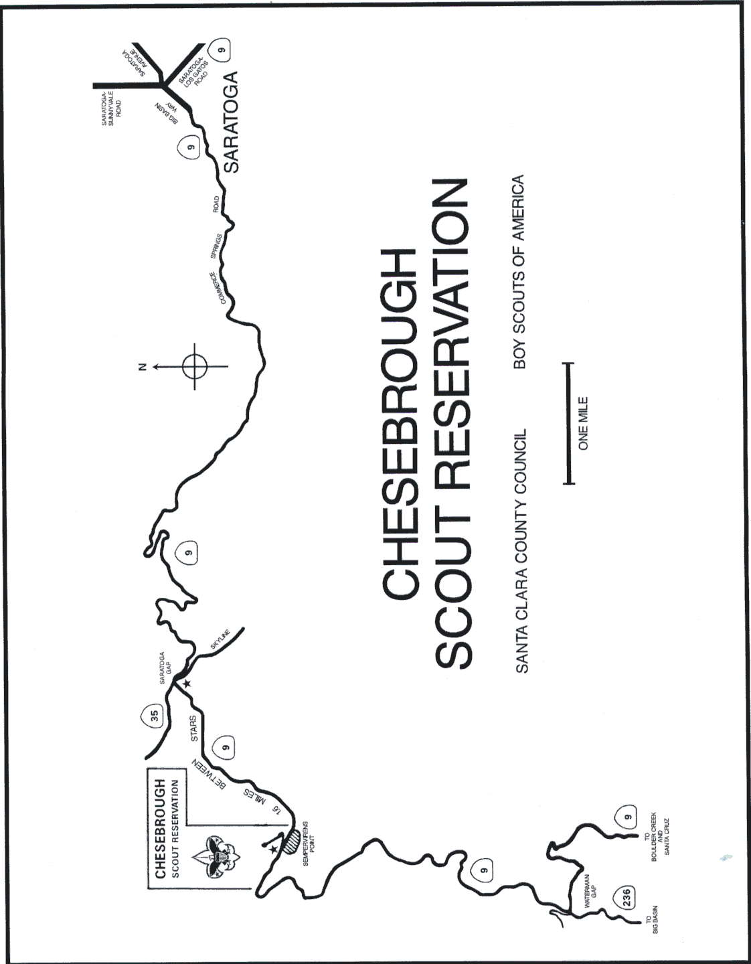

Map of Chesebrough

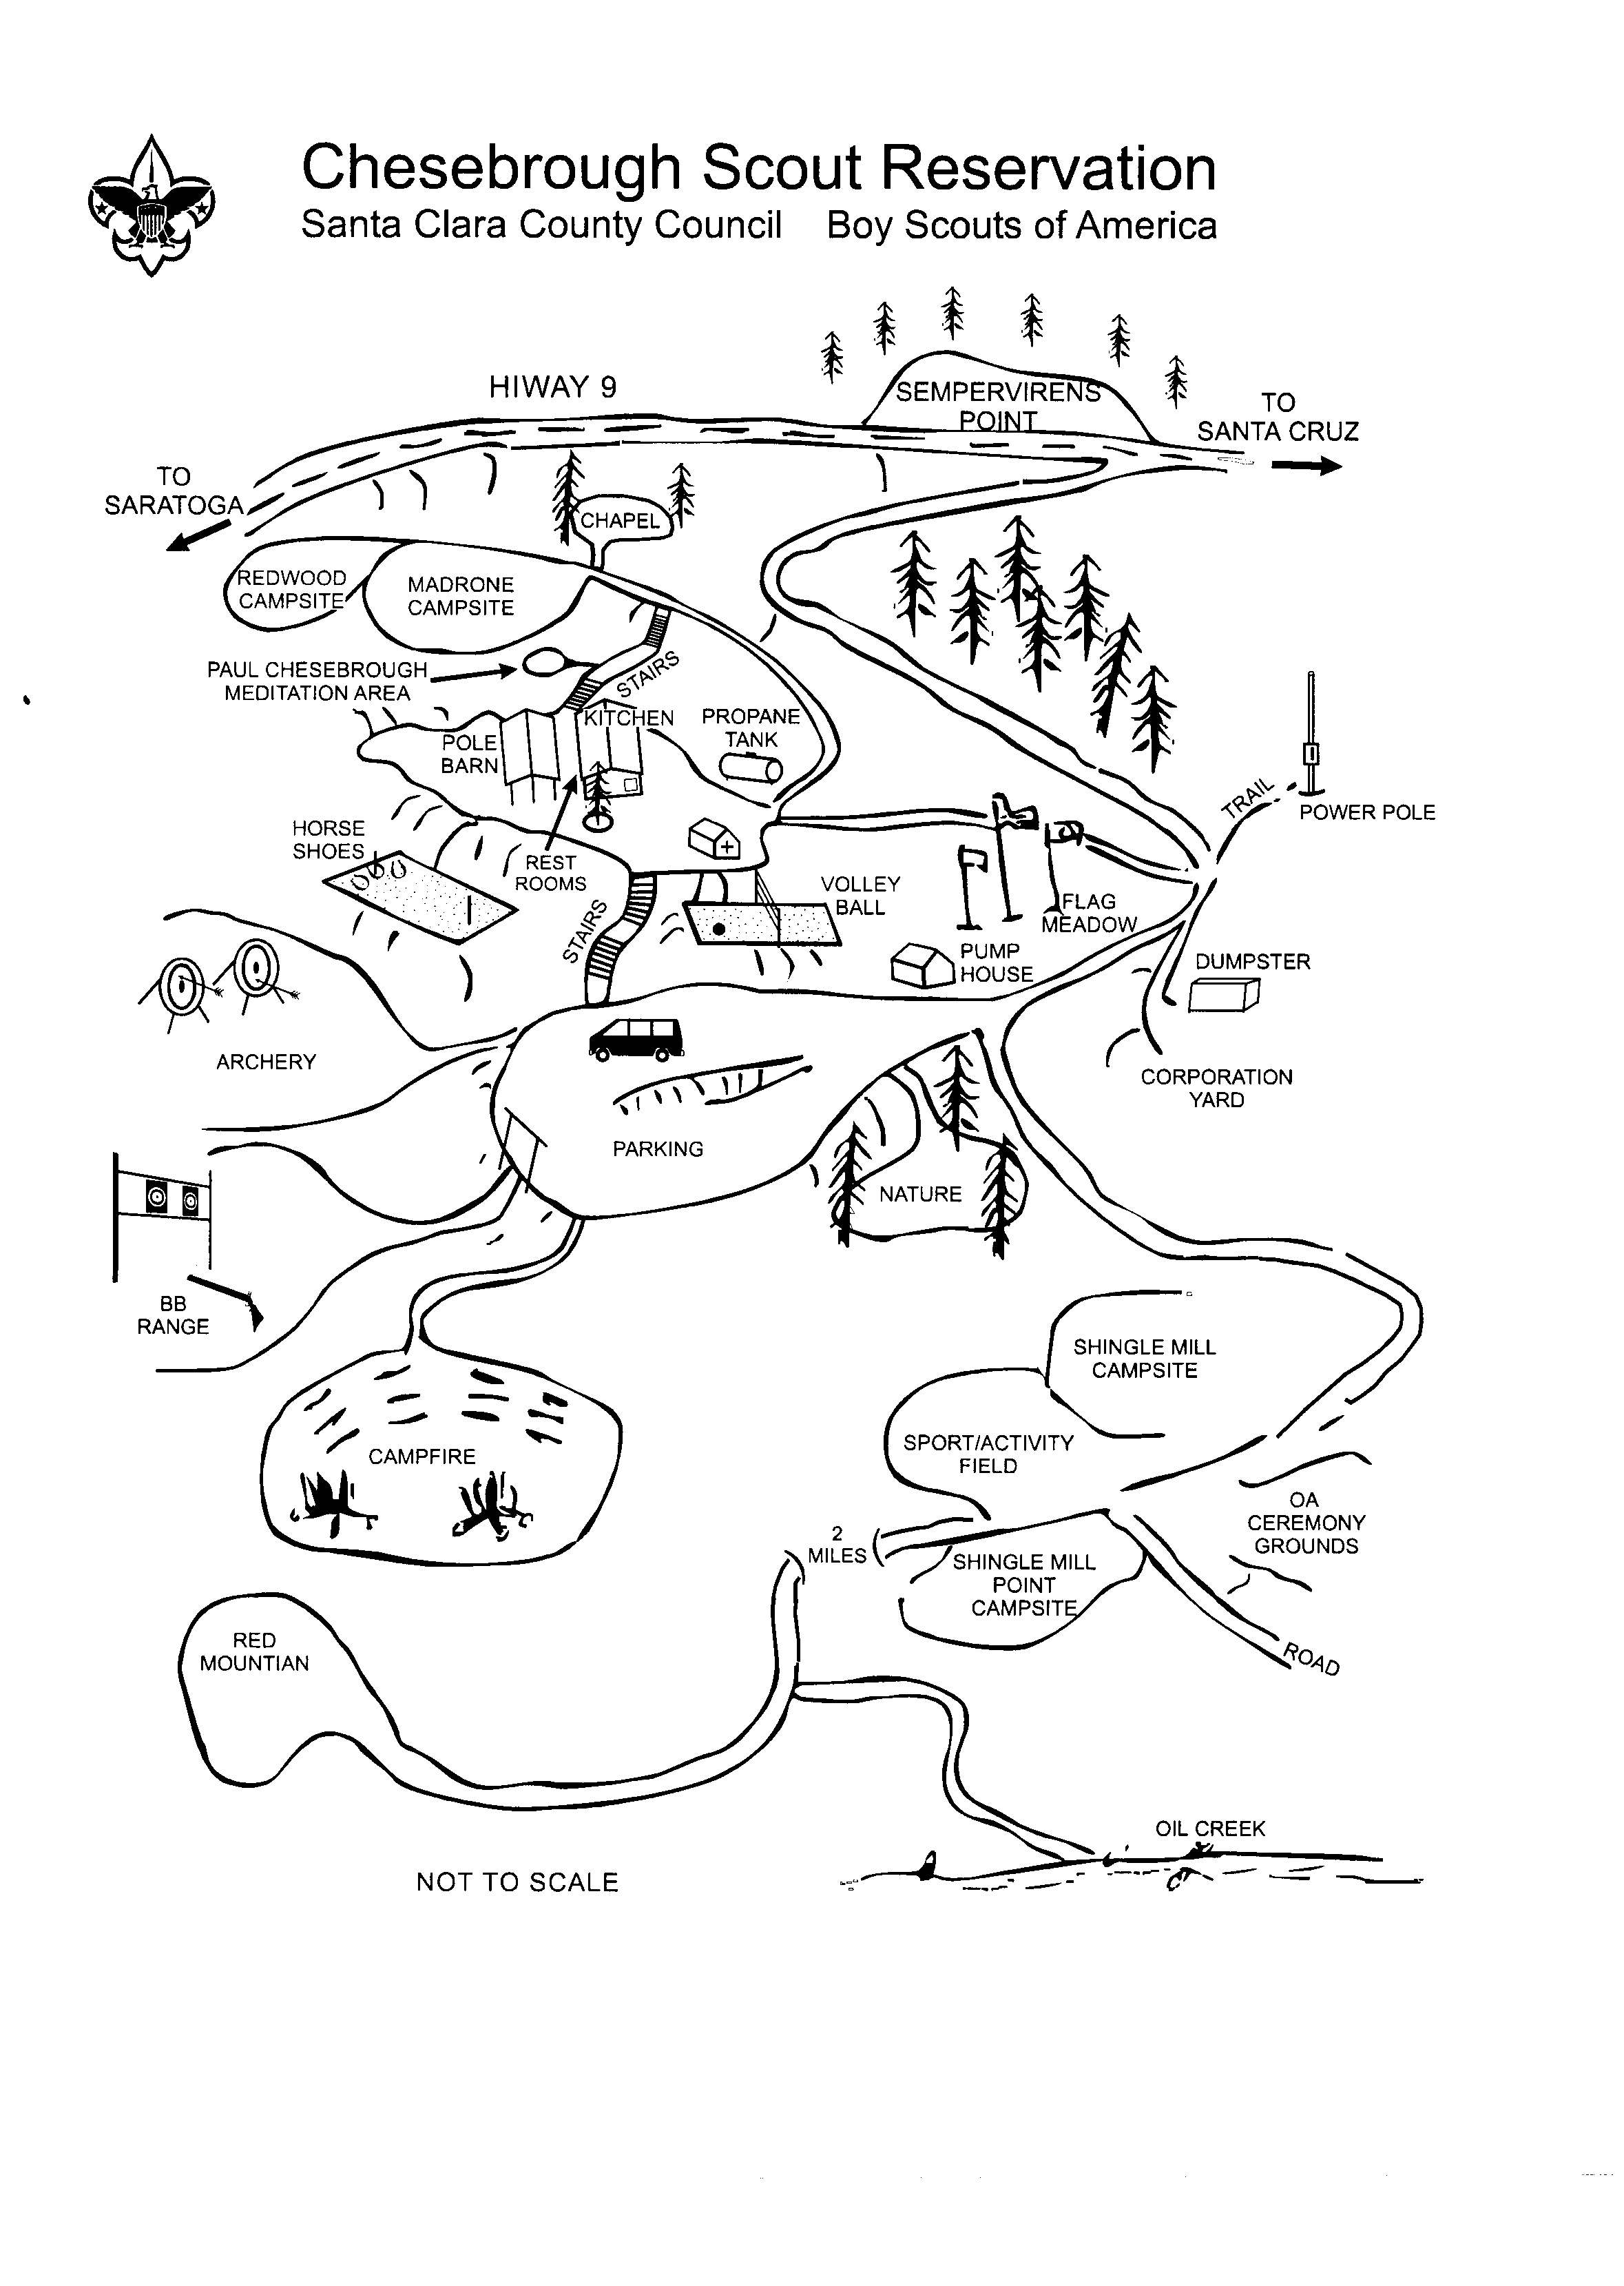
Emergency Consent Form for Minors

Santa Clara County Council Boy Scouts of America

Emergency Consent form for Minors

I/We, the undersigned, parent(s) or guardian(s) of ________________________, a minor, do here by authorize the adult leader(s) to charge as agents for the undersigned to consent to any x-ray examination, anesthetic, medical, dental or surgical diagnosis, care or treatment and hospital care which is deemed advisable by, and is rendered under the general special supervision of any physician and surgeon licensed under the provisions of the Medical Practice Act on the medical staff of any accredited hospital, or a licensed dentist, as the case may be, whether such diagnosis or treatment is rendered at the office of said physician or dentist or at the said hospital, or elsewhere as circumstances may require in the discretion of the treating physician or dentist.
It is understood that this authorization is given advance of any special diagnosis, medical or dental care and hospital care being required, but I given to provide authority and power on the part of our aforesaid agent(s) to give specific consent to any and all such diagnosis, medical, dental or hospital care which the aforementioned physician, in the exercise of his best judgment, may deem advisable. This authorization is given pursuant to the provisions of Section6910 of the Family Code of California.

This authorization shall remain in effect until__________,20___, unless sooner revoked in writing, delivered to said agent(s).

Signature(s) of Parent(s) or Guardian(s)

_____________________________________________Date_______________

_____________________________________________Date_______________

