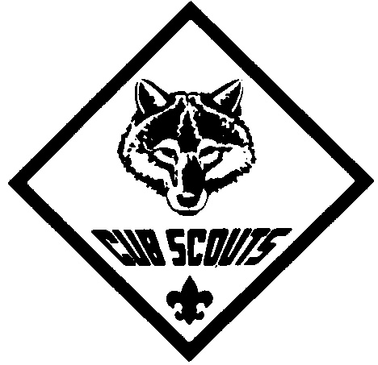
Let's Celebrate Scouting

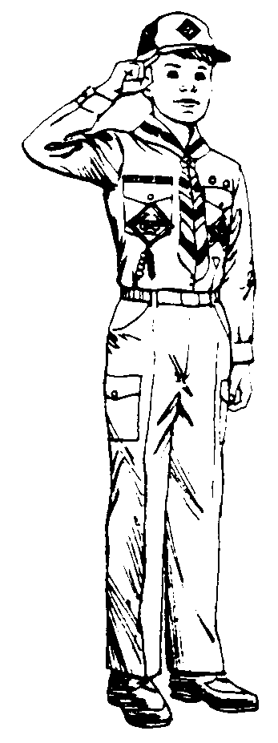

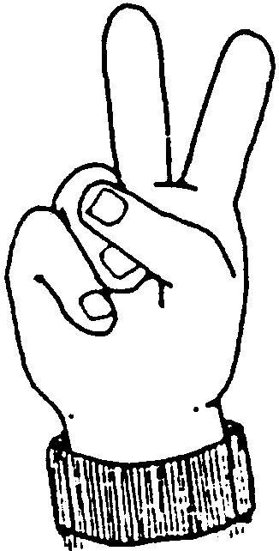

FEBRUARY 1998

A HUNDRED YEARS FROM NOW

A hundred years from now
‘Twill not matter at all
What your bank account was
Whether large or small
The kind of house you lived in

‘Twill be immaterial, too
As will the kind of car you drove
And the famous folks you knew
But the world may be a better place
Because you gave your time to Scouting
To guide future leaders down life’s trail
So keep that Scouting light shining
As a beacon light for each boy
Then in years to come you’ll see them as men
Who fill you with pride and joy
Yes, Scouting is ..........that boy

FEBRUARY ACTIVITIES

ANNIVERSARY WEEK ACTIVITIES
For suggestions for the anniversary week activities, see Cub Scout Leader How-to Book, pages 9-49 to 51, and Cub Scout Leader Book, page 9-10

BLUE AND GOLD BANQUET
The Blue and Gold banquet is probably the most exciting event of the whole year because it is a birthday party for Cub Scouting in which all families can take part in. The banquet is held in February, the Anniversary month of the Boy Scouts of America. Because it is a larger event than your monthly pack meeting, you will be taking additional planning steps to make it a success. For suggestions in planning a Blue and Gold banquet, see Cub Scout Leader How-to Book, pages 9-52 to 9-62, and Cub Scout Leader Book pages 7-20 to 7-22.
An important thing to remember in planning your Blue and Gold decorations is that most Cub Scout-age boys like to keep the cut and paste activities to a minimum. They will get excited about making and planning the decorations for Blue and Gold, but if the project is too involved and takes more than a couple of den meetings to complete, they will likely tire of it before the decorations are all finished.

FELLERS CAKE BAKE
For recommended rules for the fellers cake bake, see Cub Scout Leader How-to Book, page 9-51

HOW IT ALL BEGAN

On February 22, 1857, the shrill voice of a newborn baby boy was heard from the home of a family of gentlefolk in England. That voice was to be heard around the world. Over the next eighty years, the voice cried out for world friendship, international understanding and fellowship among the boys from every land. This was the voice of Robert Stephenson Smyth Baden-Powell.
In his lifetime, Robert Baden-Powell did many things and all of them well. He was a student, illustrator, author, soldier, but most of all, he was a leader of men and boys.
Baden-Powell wrote a book called Aids to Scouting to train the English Army. Many people were interested in his book, so he began to think that the same ideas might be used to train boys as well as soldiers. To try out these ideas, he held a camp for 22 boys on Brownsea Island, Dorset, in 1907. They swam, signaled, hiked and played games. Scouting had begun!
Scouting was seen to be so much fun that before long younger boys were asking to become Scouts. So in 1916 Baden-Powell started the Wolf Cubs to provide fun and adventure for boys aged 8 to 11. Wolf Cubs learned to light fires, use a compass, give first aid and keep themselves fit and healthy, as well as many other things. They also played games and went on outings. Cubbing had begun and soon it began to grow and grow.

HOW SCOUTING CAME TO AMERICA

In the fall of 1909 an American publisher, William D. Boyce from Chicago was in London, England on business. A dense fog made getting around in the city difficult and Mr. Boyce stopped under a street lamp to get his bearings. Out of the fog a young boy approached him and asked if he could help. So the boy helped Mr. Boyce find the business office he was looking for. When they had arrived there, Mr. Boyce began to give the boy a tip. "No, thank you, sir. Not for doing a good turn." And why not, Mr. Boyce inquired. "Because I am a Scout--and a Scout doesn't take anything for helping." "A Scout? And what might that be?" The boy, then told the American about the Boy Scouts and even took him later to meet the founder of Scouting, Robert Baden-Powell. Just a few months later on February 8, 1910, Mr. Boyce and some other Americans met in Washington, D. C., and incorporated the Boy Scouts of America.

THE EVENTS OF CUB SCOUTING IN AMERICA

1910 Boy Scouts of America incorporated on February 8.
1912 Boys' Life magazine became official publication.
1913 Scouting magazine was born.
1930 The National Executive Board approved the Cub program for boys 9 to 11 on February 10. Cub books were issued including: Wolf, Bear, Lion, Parent's Cub Book, and Cub Leader's Outline. A complete uniform for boys was $6.05. During the first year 5,102 boys and 1,433 pack leaders in 243 packs were registered.
1936 Registrations of den mothers was made "optional"; before this year, it was not permitted. Cubbing reached 10 percent of the total of all boys registered in the Scouting program. Registrations: 114,515 boys and 19,296 pack leaders.
1938 First International Cub Leaders Conference at Gilwell Park, England. Bobcat pin was introduced for civilian wear.
1942 Cubs were allowed rank corresponding to age if late entry into the program (no need for "catch-up").
1943 First Blue and Gold Banquet.
1945 "Cubbing" changed to "Cub Scouting."
1948 All den mothers must register with BSA (optional before).
1949 The age levels for Cub Scouting were changed to 8, 9, and 10 with boys entering Boy Scouting at 11 years of age. At the end of its 20th year, Cub Scouting exceeded the million mark for the first time in boy registration.
1955 First Pinewood Derby.
1956 First Cub Scouting books in Braille.
1959 Bobcat Pin introduced for the uniform.
1960 The Golden Jubilee of Scouting and 30th Anniversary of Cub Scouting in the U.S.
1964 National Summertime Award created to encourage year-round Cub Scouting. Cub Scout Swim Plan introduced.
1967 The Cub Scout Advancement Program was overhauled. The Lion rank was discontinued in favor of the new Webelos Scout program with its distinctive uniform and 15 activity badges. Ten-year-olds became Webelos Scouts after two years in the Cub Scout ranks. The position of Den Mother was changed to Den Leader.
1968 Cub Scout day camps were approved by the National Executive Board.
1971 The Cub Scout Promise was changed from "to be square" to "to help other people."
1972 New embroidered badges for Bobcat, Wolf, Bear and Webelos.
1975 Webelos transition program launched.
1976 Women were allowed to be Cubmaster or Assistant Cubmaster.
1977 Cub Scout program year changed to coincide with the school year.
1978 Five ranks established for Cub Scouting: Bobcat, Wolf, Bear, Webelos, Arrow of Light.
1980 The 50th Anniversary of Cub Scouting in the United States. 30 million Cub Scouts were registered since 1930. New uniform designs for boys and leaders.
1982 The 75th Anniversary of World Scouting. Tiger Cubs, BSA, was introduced at the Atlanta National Meeting.
1984 Extended camping was approved for Webelos Scouts.
1986 Cub Scouting was expanded to serve all elementary school grades.
1987 Five more Webelos activity badges were introduced, for the total of 20 activity badges.
1995 The 75th Anniversary of the Santa Clara County Council.
1996 Tiger Cubs are now members of the Cub Scout pack as a Tiger Cub den. Tiger Cub program was reformatted to include 17 Big Ideas.
BANQUET QUIZ

How much do you know about Cub Scouting? Can you answer these questions?

1. Cub Scouting is ____ years old this month.
2. Scouting is ____ years old this month.
3. ___________ ___________ is the founder of Scouting.
4. _______________ is the first rank in Cub Scouting.
5. (number) achievements are required to earn the Wolf Badge.
6. (number) electives are required to earn a Gold Arrow Point.
7. There are (number) Webelos activity badges which can be earned.
8. The ___________ of ____________ is the highest award in Cub Scouting.
9. We belong to Pack No. ____.
10. We belong to Den No. ____.
11. There are (number) in our den.
12. ___________ _____________ is our Cubmaster.
13. Our pack is part of _______ District, in the _______ _______ _______ Council.
14. (For parents only) My son is working on his ____________ rank.
15. (For boys only) I need only (number) more requirements to earn my next rank.
16. The Cub Scout Motto is, "_________ _________ __________."
17. What is the first requirement of a new Cub Scout?
18. How old is a boy when becoming a Webelos?
19. What is the color of a Bear neckerchief?
20. What are the colors in a Webelos ribbon?
21. Where does the flag go on a Cub Scout uniform?
22. Tiger Cub boys are in the _______ grade.
23. What country did Scouting start in? _____________
24. The Cub Scout colors are __________ and __________.
25. Who was responsible for incorporating the Boy Scouts of America?
26. What is the Anniversary date of the Boy Scouts of America?
27. What is the Anniversary date for Cub Scouts in America?
28. What color background is warn with Cub Scout service stars?
29. What color background is warn with adult leader service stars?
30. Boy's Life is (1) an autobiography requirement for the Wolf badge (2) a current movie (3) a magazine for boys (4) a new TV show.

BANQUET QUIZ Answers: 1) 68; 2) 88; 3) Robert S. S. Baden-Powell; 4) Bobcat; 5) 12; 6) 10; 7) 20; 8) Arrow of Light; 16) Do Your Best; 17) Bobcat; 18) 4th grade; 19) Light Blue; 20) Green, Yellow and Red; 21) Top of right sleeve; 22) first; 23) England; 24) Blue, Gold; 25) William D. Boyce, a Chicago Publisher; 26) February 8, 1910; 27) February 10, 1930; 28) Yellow; 29) Blue; 30) 3

BLUE AND YELLOW GAME

Give each person or group a pencil and a sheet of blue or yellow paper. They should write down as many things as they can think of that are blue (sky, flowers, sapphires, Cub Scout uniforms, etc.) or yellow (crayons, cars, hair, etc.). Prizes can be given for the longest lists or the most unusual items on a list.
FOOD CROSSWORD PUZZLE
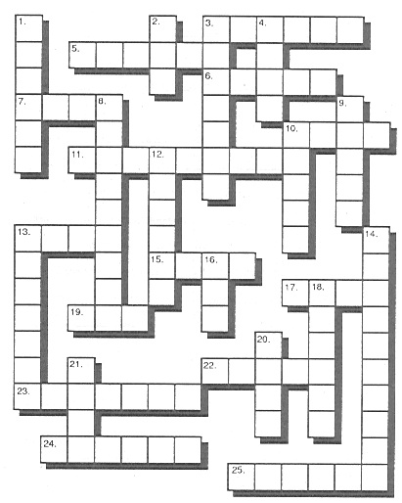

Across

3. Salt's pal
5. Rhymes with potato (in the U.S.)
6. Fuzzy fruit
7. They come from hens
10. Kind of cereal, often with raisins
11. Popular at McDonald's
13. Where the birthday candles go
15. Squirrels like these
17. Comes on a cob
19. Apple ___ or pumpkin ___
22. It can make you cry
23. Popeye's favorite
24. Tops a sundae
25. An Oreo is one

Down

1. Mice love it
2. Meat from a pig
3. Sold in a bag at the movies
4. They come in a pod
8. Often eaten with meatballs
9. Halloween treat
10. Sliced and used for a sandwich
12. Monkeys love it
13. They're Bugs Bunny's favorite
14. An orange melon
16. Instead of coffee
18. Fruit that has the same name as a color
20. Get this from a cow
21. They come from the sea

AUTOGRAPH CONTEST

Provide each guest with paper and pencil and tell him to get the autographs of as many other people as possible. The person who gets the most autographs earns a Big Round of Applause. For variation, ask that autographs be written with the left hand.

BOY SCOUT HANDSHAKE MIXER

Upon arrival, each person is instructed to introduce himself and shake hands with all the others with his left hand and to use only his left hand for any activity until everyone is present.

BLUE AND GOLD OPENING CEREMONY

Personnel needed: Narrator (Cubmaster) and four Cub Scouts.
Preparation: 4 quart size jars with lids are needed (e.g. mayonnaise).
For 3 of the lids, place 5 drops of food coloring on the underside of the lid and allow to dry. Use Blue, Yellow and Red food coloring. Mark the lids with B-blue, Y-yellow, R-red and C-clear (no color). Fill the 4 jars 1/3 full of clear water.

Cub #1 holds up a jar of water with the lid marked "B." The water will be clear. Cubmaster: "The main color of our Cub Scouts is blue." Cub #1 shakes the bottle and the water changes to blue. "Blue represents the color of our sky, clean and pure in its blue, as does the blue in our flag which stands for justice and pure virtues."
Cub #2 holds up a jar of water with the lid marked "C." The water will be clear. Cub #2 shakes the jar and the water stays clear. Cubmaster: "The water in the jar is still clear and clean and pure. The white in our flag's stars and stripes also stands for purity and our dreams for a better tomorrow in both thought and deed - a rule of conduct we all should heed. A reminder that all of our lives need to stay clean and pure."
Cub #3 holds up a jar of water with the lid marked "Y" and shakes it. The water changes to a yellow-gold. Cubmaster: "Yellow or gold is the other main color of our Cub Scout colors. Yellow or gold represents the sunshine and happiness of our lives. Health and happiness in a land of abundance and prosperity."
Cub #4 holds up a jar of water with the lid marked "R" and shakes it. The water turns red. Cubmaster: "The color in this jar represents the red stripes of our flag. It reminds us that many people with courage and bravery have given their lives and their blood to protect this land and our freedom."
Cubmaster: "Let's now pour the clear water into the gold water. (Pour) We still have the sunshine of life and happiness. Let's now pour the blue into the gold water. (Pour) We now have the magic of green. Our country is a country of beautiful green valleys and beautiful mountains of green, a true land of freedom. Blue and gold have blended together to show we can work together for a better world."
"Now as we pour the red into the green, the jar turns black. (Pour) So it is with our lives. If we live good lives that bring us happiness, the sunshine will always be there. The black illustrates that when we do things that are not right, our lives are filled with sadness or unhappiness because of our wrong doings. Let us all strive to follow the path of the green."
"Will you now join me in the Cub Scout Promise!"

GREAT EVENTS OF SCOUTING - OPENING

Cubmaster: On the 29th of July in 1907, Lord Baden-Powell took 22 boys with him to Brownsea Island, off England's southern coast. This was the world's first Scout camp. That little camp was the foundation of the tremendous world-wide Scouting movement The Boy Scouts of America was organized along with Scouting associations in many countries. Today there are more than 15 million Scouts and leaders in over 150 countries. Time changes many things, but the Scout Promise and Law are as important today as they were in the beginning. Please stand, give the Cub Scout sign and repeat the Cub Scout Promise with me, followed by the Pledge of Allegiance.
CUB SCOUT IDEALS - OPENING

Have five Cub Scouts holding signs come forward on stage one at a time, as the narrator (pick a leader with a loud, clear voice) reads the message. The signs should read (have them large enough so that people at the back of the audience can read them) Honest, Loyal, Happy, Fair, and Game.

Narrator: Every real Cub Scout has ideals. He has some very definite things he tries to live up to. These things are very important.

First, a Cub Scout is Honest, because he has discovered that honest people are the only kind of people he likes to be around. Crooked people are so unfair, even to themselves -- so the Cub Scout follows the law of man and of God -- and is honest with everybody. A Cub Scout is reliable!

Second, a Cub Scout is Loyal. He sticks by his friends, his home, his school, his religion, his country. Everyone likes to have a Cub Scout for a friend because he is loyal to them and to the big things that Cub Scouting stands for. You can depend on a Cub Scout -- he doesn't change like the weather.

Third, a Cub Scout is Happy. A smile is a language understood in every land. Even animals know a smile. Smile at a dog and he wags his tail. Frown at him and he drops his tail. Smiles are catching! Give one to others and they catch one from you. Sometimes a Cub Scout puts on a smile for others when he's really a bit low in spirit and then a funny thing happens -- the outside smile penetrates right inside and the first thing he knows, he feels happy on the inside, too.

Fourth, a Cub Scout is Fair. In anything he does with others, he takes no advantage. He treats the other fellow as he would like to be treated himself. In games and competition, too, the Cub Scout is fair to the other fellow.

Fifth, a Cub Scout is Game. He can stand pain without crying. He doesn't quit even if others are way ahead of him in the race -- he carries right on. If he loses, he doesn't whimper or get mad. When things go against him, he never gives up, but still "does his best."

These five big things, one for each finger of the Cub's left hand; the one nearest his heart; and the one used in the Living Circle (Five Cubs lay aside signs and join in Living Circle, repeating the Cub Scout Promise).

(The ideas in the above ceremony in the main were taken from "The Boys Cubbook" issued in 1930 by the B.S.A. It is interesting that today, sixty eight years later, the same ideals are just as important in helping Cub Scouts become better citizens.)

INTERPRETATION OF THE CUB SCOUT PROMISE
(Opening or Closing Ceremony)

ARRANGEMENT: Six Cub Scouts hold cards, on which are printed parts of the Cub Scout Promise as shown below. Each Cub Scout holds up his card in turn and reads the explanation given below.

I, __________, Promise . . . A promise is a solemn vow, where your reputation is at stake.

To Do My Best . . . Your best is giving all you've got when you have something to do, and working on it with all your heart and with all the strength and devotion you have.

To Do My Duty . . . To do the job, to meet the responsibilities, to do what must be done, not just half-way, but completely and fully so that you're proud of your work.

To God and My Country . . . First, duty to God. Fulfill your religious responsibilities and uphold your religious beliefs. Second, duty to country. I know you've been told how lucky you are to live in a free country and I hope you are aware of what freedom means. You should try to be a good citizen.

To Help Other People . . . To help -- it doesn't say how much. It could mean saving a life or changing a tire or carrying a bag of groceries. To help other people -- not just your own family. The best time to help is when you have to go out of your way to do it.

To Obey the Law of the Pack . . . So that we will all remember just what this law includes, will you please stand and repeat it with me?

(Boys lead audience in saying the Law of the Pack, giving the Cub Scout sign.)

BLUE AND GOLD COLORS
(Closing Thought)

As we close our meeting, let's give a thought to what we have seen about the meaning of the Blue and Gold colors. Did you notice that the Blue and Gold you see on the Cub Scout uniform was not selected merely because it was attractive? The meaning behind these two colors is very important to each of us as we strive to live our lives in truth and spirituality with steadfast loyalty represented by our blue, and the feeling of warmth of the sun reminds us to be of good cheer as well as give good cheer represented by our gold. So, may the meaning of these two colors shine forth in our lives as we bring the Scouting program into the lives of our boys. Let us go forth from here determined that we will develop among ourselves and our boys that comradeship through the worldwide spirit of Scout brotherhood, so that we help to develop peace and happiness in the world and good will among men.

LORD BADEN-POWELL'S FAREWELL MESSAGE
(This letter was found among Baden-Powell's papers after his death January 8, 1941)
(Read at closing)

Dear Scouts,

If you have ever seen the play "Peter Pan," you will remember how the pirate chief was always making his dying speech because he was afraid that possibly when the time came for him to die, he might not have time to get it off his chest. It is much the same with me and so, although I am not at this moment dying, I shall be doing so one of these days and I want to send you a parting word of good-bye.

Remember, it is the last you will ever hear from me, so think it over.

I have had a most happy life, and I want each one of you to have as happy a life, too.

I believe that God put us in this jolly world to be happy and to enjoy life. Happiness doesn't come from being rich nor merely from being successful in your career, nor by self-indulgence. One step toward happiness is to make yourself healthy and strong while you are a boy, so that you can be useful and can enjoy life when you are a man.

Nature study will show you how full of beautiful and wonderful things God has made the world for you to enjoy. Be contented with what you have got and make the best of it. Look on the bright side of things instead of the gloomy one.

But the real way to get happiness is by giving out happiness to other people. Try and leave this world a little better than when you found it; and, when your turn comes to die, you can die happy in feeling that at any rate you have not wasted your time but have done your best. "Be prepared" in this way to live happy and to die happy - stick to your Scout promise always even after you have ceased to be a boy - and God help you do it.

Your friend,
Baden-Powell

OUR LIVES - CLOSING

Can you say today in parting
With the day that's slipping fast
That you've helped a single person
Of the many you have passed?
Did you waste the day, or lose it,
Was it well, or poorly spent?
Did you leave a trail of kindness
Or a tear of discontent?
As you close your eyes in slumber
Do you think that God would say
You have made the world much better
For the life you lived today?

LORD BADEN-POWELL CLOSING

Lord Baden Powell had a dream
You are part of that dream
I am part of that dream
And so are we
We are part of that dream

Lord Baden Powell had a dream
And the world is a better place because
He made his dreams come true
Lord Baden Powell had a dream
Do you have a dream?

The world may be a better place
If you work to make your dream come true
Goodnight and happy dreams

BANQUET INVOCATION

O Lord, that I will do my best,
I come to Thee in prayer.
Help me to help others every day
And teach me to be fair;
To honor mother and father,
And to obey the Cub Scout Law, too.
This I ask that I may be
A loyal Cub Scout true.

INVOCATION

Oh God, the giver of all good things,
Grant that we may be good Cub Scouts this
day;
Not only to be good,
but also to do good by helping other people.
Help us to do our best to live up to the Cub
Scout Promise.
We pray these things in Your holy name.
Amen.

PRAYER FOR SCOUTING'S BIRTHDAY

Dear God, please bless our pack especially this day when we are celebrating our birthday. Bless all Cub Scouts everywhere. Bless all boys and men who have been Cub Scouts in the past, wherever they are now. May they always remember their Cub Scout Promise and do their best to serve you, as we are trying to do. Bless all who are members of our Pack now and help us to be worthy Cub Scouts, not only of this Pack, but of the world-wide brotherhood of Scouting. Amen.

More Blue and Gold opening and closing ceremonies:
Cub Scout leader How-to Book
"Blue and Gold Ceremonies for God and Country," "Story of Cub Scout Colors," and "Scouting Around the World" (p. 9-56)
"Cub Scout Spirit," "The Blue and Gold," and "Closing Thought" (p. 9-57)
"A Cub Scout Parent's Prayer" (p. 9-58)
Staging Den and Pack Ceremonies
"Story of Cub Scout Colors" (pp. 81-82)
"Red, White, and Blue Over Blue and Gold" (p. 38)
"A Dinner Closing" (pp. 59-60)
"Closing Thought" (p. 31)
"Closing Thought - Lord Baden-Powell (p. 58)

BLUE AND GOLD ADVANCEMENT

Cubmaster or advancement chair:

Blue and Gold, the Cub Scout colors, stand for some of the good things Cub Scouts gain through the process of advancement as they make progress through the ranks.

Gold stands for good cheer. The boys here who have learned the basics of Cub Scouting and have earned their Bobcat badge are full of the good cheer of Cub Scouting.

Will these boys and their parents please come forward?
(Call names of boys receiving Bobcats - give award to the parents to pin on the boy.)

Gold also stands for happiness, and no one seems to be more full of happiness than these bright young men who have completed the twelve achievements necessary for the rank of Wolf. Will these boys please come forward with their parents? (Call names of boys receiving Wolf badges and Wolf arrow points. Give awards to the parents and have them present them to the boys.)

Blue, the other color of Cub Scouting stands for truth. Truth begins to shine through strong on the faces of these Cub Scouts, as they have completed the achievements for the rank of Bear and have learned that Cub Scout honor really is important and truth is always the best. Will these boys come forward with their parents? (Call names of those boys receiving Bear badges and Bear arrow points. Give badges to the parents to present to the boys.)

The other meaning for the color Blue is loyalty. This is one of the most important traits a boy can learn in the process of becoming a man. Loyalty to family, God, country, friends and most important, loyalty to his beliefs and convictions. There are many adults who do not display this trait, but the boys who have progressed to the rank of Webelos have developed, or are developing, this trait of loyalty. The boys who have earned honors as Webelos are: (call off names and at this time award activity badges, and also the Arrow of Light. Just say a few words about the accomplishments of each boy. Honor the Arrow of Light recipients with more ado than the activity badge recipients.)

These boys honored tonight have been true to the gold and the blue by showing the traits represented by our Cub Scout colors...Good cheer, Happiness, Truth, and Loyalty. Let's now show them and their parents how much we admire their efforts with a Pack cheer.

"Who's the best in the Blue and Gold? Pack ____ so we've been told!"

THE CUB SCOUT BIRTHDAY BOX ADVANCEMENT

Arrangements: The Cubmaster enters the room with a very large box wrapped as a birthday present. Usually it is on a wagon or a cart so it can easily be pulled. There is a large bow and card on top of the birthday present. The card reads:

HAPPY BIRTHDAY CUB SCOUTS!!!

Inside the large box are several smaller boxes, each wrapped as birthday presents. The boxes have cards and bows on the tops. These boxes have the Den Numbers on them and read:

HAPPY BIRTHDAY CUB SCOUTS IN DEN 1, etc.

Inside the Den boxes are several smaller boxes or packages. Each package or present is labeled with the boy's name, one for each member of that den. Inside the presents are the boys awards! NOTE: Make sure every boy in the Pack gets a package. This can be done by awarding the year pins at this time. Also, since this is the Blue & Gold, there will be several awards.

Cubmaster: Since today we celebrate the birthday of Scouting, it is only appropriate that we have a birthday present. This present has Happy Birthday Cub Scouts on it. Lets see what is inside.

(The Cubmaster opens the box. He then brings out the Den boxes and as he does, he calls forward the den leaders. Each den leader takes the box with their Den number on it. Have all the den leaders stand by the Cubmaster until he gives further instructions.)

Cubmaster: Would each of the den leaders please return to their dens and open the presents?

(Den leaders return to the dens, opens the presents, and distributes the packages to each of the boys. The den leader then instructs them to open the presents.)

(After a brief pause to let the boys open their presents, the Cubmaster again calls the meeting to order and recognizes each award recipient by groups.)

Cubmaster: Would all the boys who received the Bobcat Badge please stand and be recognized. (They do so and are applauded). The Cubmaster then recognizes all awards the same way, year pins, Wolf, Bear, Arrowpoints, Webelos, Activity Badges, etc.

(Note: If there is an Arrow of Light recipient, you may opt for a separate, more elaborate ceremony.)

(Once the boys have all been recognized, the Cubmaster looks inside the box and finds one last present labeled to the Leaders of Pack ____. The Cubmaster opens the box and calls forward each leader and committee member and recognizes them.)

The ceremony is closed by singing HAPPY BIRTHDAY CUB SCOUTS!!

THE WORLD OF SCOUTING ADVANCEMENT

Arrangement: Have a yellow table cloth on the awards table, displaying a globe and a small set of flags from various countries.

Cubmaster: Every minute of every day of every year there are thousands of boys enjoying the fun and excitement of Cub Scouting somewhere in the world. The Cub Scout uniform varies from country to country around the world but they all have one thing in common: They promote Scouting and its goals.

Just as Cub Scouts wear different uniforms in different countries, they are also awarded different badges of rank. In Japan and Korea, Cub Scouts earn the Rabbit, Deer, and Bear Badges. In Australia, the badges are Bronze Boomerang, Silver Boomerang and Gold Boomerang. South Africa has the Tenderpad Badge.

As you know, the first badge for rank in the United States is the Bobcat. Tonight we honor _________ (name each Bobcat) who have earned this badge as they start their Cub Scout trail. Would the Bobcats and their parents please come forward?

The second badge on our Cub Scout trail is Wolf. Tonight we have ________ (name each Wolf) who have earned this badge. Would the Wolves and their parents please come forward?

As the boys learn new skills, the next badge they earn is Bear. Would ________ (name each Bear) and their parents please come forward?

The next rank being presented is the Webelos badge. Webelos Scouts are preparing to become Boy Scouts. Would ________ (name each Webelos) and their parents please come forward?

These Cubs Scouts like Cub Scouts all over the world, have worked together and developed new interests which will make them better citizens of our country and of the world. Let's give them a big hand to show how proud we are of them.

BADEN-POWELL ADVANCEMENT

Have a man (Cubmaster or committee chair for example) dress up like Baden-Powell and tell the boys the most interesting facts about his life. Many of the things that would interest the boys are found in the chapters on the defense of Mafeking, in the book titled, Baden Powell. He had many experiences that the boys would love to hear, especially if it were well done. Then have him award the badges. This can be very impressive.

See Cub Scout Leader How-to Book for
"Ideas for Banquet Advancement Ceremonies" (p. 9-58)

BLUE AND GOLD DINNER

Divide the audience into 5 groups. Each group is assigned a response when their word are spoken in the story.

Blue & Gold Dinner - "Happy Birthday to You" Beans - "Yuk, Yuk"
Cubmaster - "Yes, Sir" Den Leaders - "Yipee"
Cub Scouts - "Noise, Noise, Noise"

Once upon a February an active Cub Pack decided to have a BLUE & GOLD DINNER. The DEN LEADERS and the CUBMASTER met to decide what to serve at the BLUE & GOLD DINNER. The DEN LEADERS wanted ham and chicken, but the CUBMASTER wanted BEANS. The CUBMASTER finally persuaded the DEN LEADERS to have BEANS. At last, the night of the BLUE & GOLD DINNER arrived. All the CUB SCOUTS, DEN LEADERS, and the CUBMASTER were there. Soon it arrived time to serve the BEANS, but the DEN LEADERS discovered that the BEANS were spilled all over the kitchen floor, "Who spilled the BEANS?" cried the cook. "Not us," said the CUB SCOUTS. "Not us," said the DEN LEADERS. "I cannot tell a lie," said the CUBMASTER. I spilled the BEANS."
But, all turned out well because the CUBMASTER took the DEN LEADERS and the CUB SCOUTS out to the BLUE & GOLD DINNER at a ham and chicken restaurant.
The moral of this story is - if you're a CUBMASTER, don't spill the BEANS at the BLUE & GOLD DINNER unless you want to take the DEN LEADERS and the CUB SCOUTS out for a ham and chicken dinner!

JOHNNY GOES TO A PACK MEETING

(Before you read this story, tell the audience they must do just as Johnny and the audience in the story did.)

Little Johnny went to a pack meeting with his mother and father. He grew tired of sitting still so he wiggled around in his seat (audience wiggles). Then he stood up (audience stands).
Johnny couldn't see much, so he stood on his tip-toes (audience stands on toes). Since he still couldn't see anything, he turned to the left and stretched way up on his tip-toes (audience turns left and stretches).
He still couldn't see very much so he turned to the right and stood again on his tip-toes (audience turns right, on tip toes).
Johnny thought there might be something interesting on the floor (audience kneels).
No, there wasn't anything there, so he stood up (audience stands). He took a little step to the left (audience steps left).
Now he could see. There was the Cubmaster on the platform. "Yoo-hoo Cubmaster!" he called, waving his hand high (audience waves).
At this everybody turned and scowled at Johnny (audience turns and scowls).
Poor Johnny hung his head in shame (audience bows heads). Then, they remembered he was just a boy. And with a smile on their faces, they held out their right hands (audience holds out right hands). When the Cubmaster said go, they all turned around and shook hands with the person behind them.
GO! (everyone turns and shakes hands with person behind them).
WHAT A CUB SCOUT WEARS ON HIS UNIFORM STORY

Teach the audience the following actions to give in response to the words when they are said in the story:
House: Hands over head in an inverted "V"
Closet: Show length and width with hands
Cub Scout: All Cubs stand and salute
Service Star: With one finger from each hand make an "X"
Arrow of Light: Make a triangle with two hands, point to right
Bedroom: Hands in front in "V"
Uniform: Hands start at top of head and move down toward toes
Badge(s): Make circle with thumb and finger
Arrow point: Using two hands make a triangle and point downward

Tonight we're going to show what we know about the Cub Scout uniform and the different badges. Now that you have learned the actions, just follow along with me.

This is the HOUSE where a CUB SCOUT lives. This is the BEDROOM that's in the HOUSE where a CUB SCOUT lives. This is the CLOSET that's in the BEDROOM that's in the HOUSE where the CUB SCOUT lives. This is the UNIFORM that hangs in the CLOSET that's in the BEDROOM that's in the HOUSE where the CUB SCOUT lives.

This is the CUB SCOUT who wears the UNIFORM that hangs in the CLOSET that's in the BEDROOM that's in the HOUSE where the CUB SCOUT lives. This is the Bobcat BADGE that when a boy joins, is worn on the left pocket of the UNIFORM that hangs in the CLOSET that's in the BEDROOM that's in the HOUSE where the CUB SCOUT lives.

This is the Wolf BADGE which a CUB SCOUT earns to wear on the left pocket of his UNIFORM that hangs in the CLOSET that's in the BEDROOM that's in the HOUSE where the CUB SCOUT lives.

This is the Bear BADGE which a CUB SCOUT earns to wear on the left pocket of his UNIFORM that hangs in the CLOSET that's in the BEDROOM that's in the HOUSE where the CUB SCOUT lives.

This is the Webelos BADGE which a CUB SCOUT earns to wear on the left pocket of his UNIFORM that hangs in the CLOSET that's in the BEDROOM that's in the HOUSE where the CUB SCOUT lives.

This is the SERVICE STAR that he earns every year and wears above the pocket where he wears his Bobcat, Wolf, Bear, and Webelos BADGES on his uniform. And this is the ARROW OF LIGHT which is the highest award a CUB SCOUT can earn, and is worn centered on the pocket flap of the same pocket where he wears his other BADGES on his UNIFORM that hangs in the CLOSET that's in the BEDROOM that's in the HOUSE where the CUB SCOUT lives.

Now look. You're all wearing your UNIFORM. It's not hanging in the CLOSET that's in the BEDROOM that's in the HOUSE where the CUB SCOUT lives.
UNIFORM INSPECTION SKIT

CHARACTERS: Denner, Den Chief, and any number of Cub Scouts
SETTING: Pack Meeting

DENNER: Cub Scouts of Den ____ line up! (they line up)
Den Chief, we are ready for our uniform inspection.

DEN CHIEF: (inspects all Cub Scouts -- but not too slowly)
They all look great! ..... except for Johnny.

JOHNNY: Me?

1st Cub: You mean Johnny?

2nd Cub: You mean Johnny?
(continue down the line until all Cub Scouts have said the same line)

DEN CHIEF: Yes, Johnny.

JOHNNY: What's wrong with me?

1st CUB: What's wrong with Johnny?

2nd CUB: What's wrong with Johnny? (continue as above)

DEN CHIEF: Look at his socks.

JOHNNY: My socks?

1st CUB: His socks?

2nd CUB: His socks? (etc.)

DENNER: Why, Johnny, you have one green sock and one blue one!

JOHNNY: One green sock? (and so forth -- down the line)

DEN CHIEF: Yes, and one blue sock.

JOHNNY: That's funny.

1st CUB: That's funny? (etc.)

JOHNNY: Yes, I have another pair at home just like these!!

ALL OTHERS: (hit forehead with right hand) Oh, noooooo.
BUC TUOCS SKIT

Radio skit or can be adapted to a TV commercial, using live Cub Scouts or puppets. Six boys are needed.

ANNOUNCER: Boys, have you been feeling sluggish lately? Do you have that gray feeling? Do you have that over-seven feeling? I have the answer to your woes - the name is BUC TUOCS. We have with us tonight some people who have tried it and are wild about it. Here are our guests to tell you about it.

BOY #1: When I reached eight, I needed something. I was out of touch. I tried Buc Tuocs and got the lift I needed.

BOY #2: I couldn't adjust. My social life was falling apart. Buc Tuocs was the answer.

BOY #3: I was plagued by the fear of growing old. Was life passing me by? Buc Tuocs gave my life a purpose.

BOY #4: Buc Tuocs changed my life. New horizons opened up for me.

BOY #5: Girls were my problem. My kindergarten friends had gone in different directions. Buc Tuocs helped me find new friends.

ANNOUNCER: Thank you friends, for your unsolicited testimonials. Remember folks, try Buc Tuocs - it's Cub Scout spelled backward!

APPLAUSES

THE BOBCAT CHEER; Pretend to lick the back of your hand and wipe your face, like a cat does, and say MEOW, MEOW, MEOW.

THE WOLF CHEER; Make fists out of your hands and place at the side of your head, like wolf ears, then howl.

THE BEAR CHEER; Hold your hands up like bear paws with your "claws" out and GROWL

THE WEBELOS CHEER; Shout, WHO'S THE BEST, EVERYONE KNOWS, WE-BE-LOS, WE-BE-LOS.

THE ARROW OF LIGHT; Hold your hands out to your left side. Make an arc by moving your hands over your head to your right side while you say "WHOOOOOSH".

See Cub Scout leader How-to Book for more skits:
"Spirit of Baden-Powell" (pp. 9-58 to 9-59)
"History of Scouting" (p. 9-59)
"Cub Scout Stew" (pp. 9-59 to 9-60)
BLUE & GOLD STRINGER

People at each table form a team. Give each team a blue or gold chenille stem and several buttons (as many as will fit on the stem). At the signal, the first person strings a button on the stem and passes it to the next player, who does the same. Continue until all buttons are on the stem. First team to finish is the winner.

LEAN-TOO

A good game for the pack meeting to get the parents involved. The boys and parents stand in a circle by dens holding hands. Everyone numbers off alternately one or two. On the signal, keeping legs and backs as straight as possible, the players who are "ones" lean forward toward the center of the circle, while the "twos" lean outward. Players counterbalance each other for support. Once the group has gotten its balance, slowly reverse the leaners. Then have the players see how smoothly they can alternate.

TABLE UPSET

Can be played in a circle or with people sitting at tables (although this can be a little hectic). The leader stands in the middle of the circle or room and gives each person the name of something connected with a Blue and Gold banquet, such as a dish, knife, spoon, plate, place card, napkin ring, placemat, etc. More than one person can have the same name. The leader then makes up a dramatic story of a Blue and Gold Banquet. As he names each banquet item, the players with that item must rise, turn around and resume their seat. The leader may mention these items as many time as he chooses. Suddenly he says: "The table turned over." At this signal, all players must change seats. The leader sits in an empty chair and the player left standing becomes the new leader.

BLUE & GOLD SMILE

Divide the group or table into two teams and line them up, facing each other about 10 feet apart. Name one team "Blues" and the other "Golds." Then flip a coin and call out the side that turned up, heads means Blue and tails mean Gold. If it comes up heads, the Blues laugh and smile while the Golds try to keep sober faces. The Blues, of course, try to make the Golds laugh. Any who do laugh must join the other team. Then flip the coin again.

YANKEE DOODLE HANDICAP

Divide den or pack into teams and supply each team with some soda crackers or cookies. On a signal the first player on each team runs to the leader and is given a cookie or cracker. He eats the cookie or cracker and then whistles or sings the first verse of "Yankee Doodle," then runs back to touch the next player on the team. Continue until all have raced. The losing team serenades the winners with "Yankee Doodle."
C.U.B.S.

The Cubs sit in a circle with one beanbag in the center and the leader gives each of them a letter in order, C.U.B.S., all the way around the circle. The leader calls out one of the letters and all the boys with that letter run to the right around the outside of the circle and back through their places into the center, where they try to snatch the beanbag. The boy who gets the bag is the winner.

TOSS THE STRING

You will need a ball of yarn or string for each circle. Have the group form one or more circles of 15 or less players. The boy with the yarn starts by calling out another boy's name in the circle and tosses the yarn to him, being sure to hold the end of the string in his own hand. The boy who catches the ball must call out another name and toss him the ball, while keeping hold of the string. The object is to include everyone and create a spider web with the yarn. The leader then asks one boy to pull on his string while everyone else holds on. Ask how many boys can feel the string being pulled. Ask another one to let go of his string and see what happens to the web. Experiment with the web, have everybody pull or half of them pull. This would be a good time to talk to them about the importance of cooperation and team work. It is also an excellent time to discuss the need to help each other when help is needed, and doing it with a positive attitude.

PAPER CUT RELAY

You will need a pair of scissors and a long strip of blue or gold crepe paper for each player. All the strips should be the same length. Tie one end of each strip to a chair or tape to the floor. Give each player the other end and scissors. At a given signal, the players start cutting along the middle of the paper. The first one to cut to the other end is the winner. Divide boys into "Blue" and "Gold" teams by using equal strips of crepe paper. You can play this game in a relay fashion too. After the paper has been cut, save and use as part of your decorations for your Blue and Gold Banquet.

BLUE AND GOLD BALLOON POP

You will need an even amount of balloons in blue and gold. Separately each boy will be blindfolded and will be led to the pile of balloons. The boy has 15 seconds to reach into the pile of balloons and pull out balloons and then sit on them and pop them. Scoring: 5 points for each pair of blue and gold balloons and 1 point for extra blue or gold balloons.

For more Blue and Gold games,
see the CubScout Leader How-to Book, pp. 9-60 to 61.

BLUE & GOLD
(Tune: Clementine)

We're the Cub Scouts (boys)
We're the Scouters (adults)
Here we are both young and old (all)
Altogether we're a Cub Pack,
Having fun at Blue and Gold.

Tigers and Bobcats (Tigers & Bobcats)
Wolf and Bear Cubs (Wolves & Bears)
And the Webelos are we. (Webelos)
Altogether we're a Cub Pack
Having fun in harmony.

We're the mothers (moms)
We're the fathers (dads)
Helping Cub Scouts as they go. (adults)
Up the ladder of achievement,
Climbing higher as they grow.

Let's give thanks (everyone)
On this occasion
To the mighty Gold and Blue;
Pack ______ is the number
Representing me and you.

NO BUSINESS LIKE CUB BUSINESS
(Tune: No Business Like Show Business)

There's no Cub Scouts like our Cub Scouts
Cause our pack is the best.
Everything we're doing shows we're eager
Working on the skits and games and songs,
Going on the field trips with our leaders,
And having fun as we go on.

There's no Cub Scouts like our Cub Scouts.
We smile each time we meet.
Even when we're nervous we will do our best.
We hope our parents will do the rest.
So you see in Cub Scouts we have passed
the test.
Let's go on, watch us grow.

BIRTHDAY BSA
(Tune: On Top of Old Smokey)

We were all at the banquet
On Blue and Gold day,
The whole family came there
To eat and to play.

Then somebody told me
We're 68 years old.
I could not believe
What I had been told.

They brought out a cake
With candles atop.
I counted the candles,
And I didn't stop.

Now how could a Cub Scout
Be age 68?
When I get that old,
I'll be using a walking stick.

Then somebody told me
An astonishing fact.
The Boy Scouts of America
Is older than that!

My den leader told me,
That I shouldn't fret
That's the age of Cub Scouting,
I'm not that old yet!

WE'RE A CUB SCOUT PACK
(Tune: You're A Grand Old Flag)

We're a Cub Scout Pack,
We're a high flying pack
Down the trail of Akela we'll go.
From Wolf to Bear to Webelos,
As into good Cub Scouts we grow.
Every Cub is true to the Gold and the Blue
And he never forgets the fact
That all the fun a boy could want,
He can find in a Cub Scout Pack!

BLUE AND GOLD, THE BEAUTIFUL
(Tune: America the Beautiful)

O, beautiful for Blue and Gold,
And what the colors mean,
Standing for skies above, we're told,
And Truth and Spirituality!
The Blue and Gold, the Blue and Gold!
For Loyality Steadfast,
And Sunlight warm, and Good Cheer, to;
Bringing Happiness to last!

THANK YOU LORD
(Tune: Edelweiss)

Thank you Lord on this day,
For our many good blessings,
Thank you Lord on this day,
For our many close Scout friends.
Glory to God, may you hear our prayer
Guide us on forever,
Thank you Lord on this day,
For our blessings and Scout friends

BE KIND TO YOUR CUB SCOUTING FRIENDS
(Tune: Stars and Stripes Forever)

Be kind to your Cub Scouting friends,
That's a pledge from one Scout to another.
Be kind to your leaders today,
Cause for helping, they get no pay.

Be kind to your neighbors and friends,
Cause by caring you follow Scouting's letter.
Cub Scouting and friendship are grand.
And as we grow, the world will know,
We've made things better.

See Cub Scout Songbook:
"Think Blue"
"Thank You For the Food We Eat"
"Bless This Food"
"Recognition Song"
I'VE BEEN WORKING IN THE CUB SCOUTS
(Tune: I've been working on the railroad.)

I've been working in the Cub Scouts,
For the Blue and Gold.
I've been working in the Cub Scouts,
There's food that's hot and cold!
Can't you see the smiling faces,
Mom and Dad 'n Aunt Sue!
Aren't you happy that you joined us?
Scouts are for you too!

For the Blue and Gold,
For the Blue and Gold,
For the Blue and Gold,
We came for fun.

For the Blue and Gold,
For the Blue and Gold,
For the Blue and Gold,
We came (YELL) FOR FUN!

Tigers, Wolves, and Bears and Webelos,
Parents, Leaders, and Guests you know,
Everyone in our pack is happy,
Celebrating Blue and Gold!

We're singing, Scouting, Scouting HI HO,
Cub Scouting for me, I know!
Scouting, it's for Families
On the Scouting Trail we'll Go! HOORAY!

CUB SCOUT TAPS

Sun of Gold,
Sky of Blue
Both are gone
From our sight,
Day Is through.
Do your best
Then to rest
Peace to you.

INVITATION
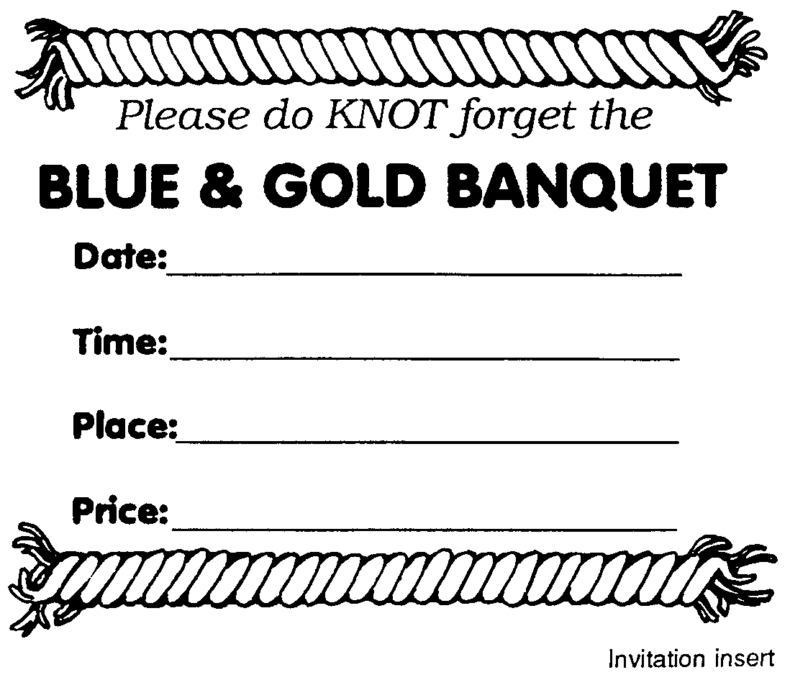

Supplies Needed: Blue construction paper
Yellow Construction paper
Scissors and Glue
Cub Scout stickers (optional)

Directions:
1. Cut both halves out of blue paper. Fold on line.
2. Cut yellow set-in and glue in place
3. Use the invitation given below, inserting appropriate information.
The invitation is folded so one half can be detached and returned to you.

Expand the hat
pattern and
use it as a
placemat.
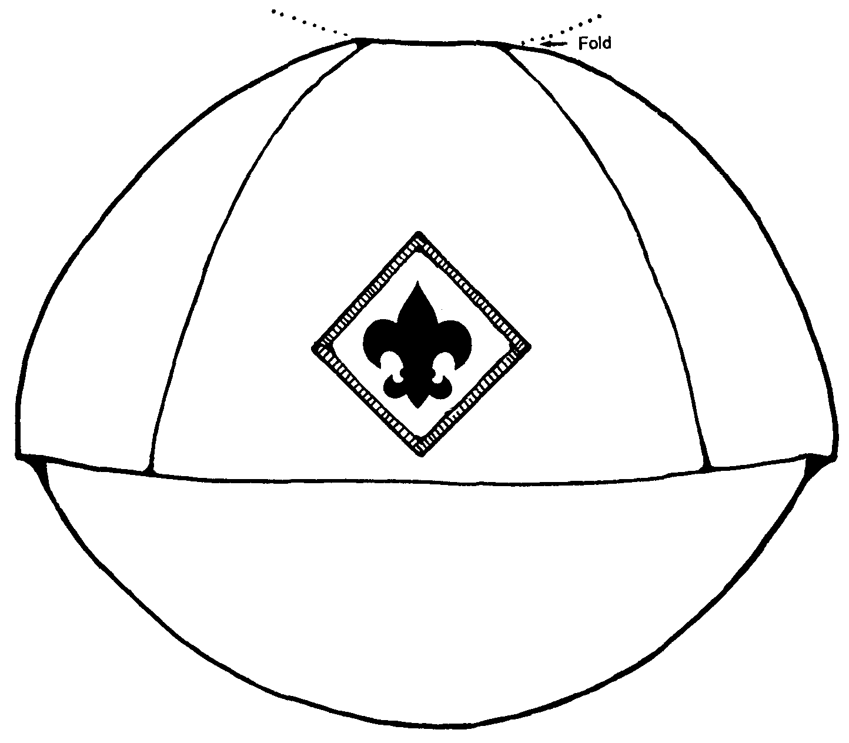

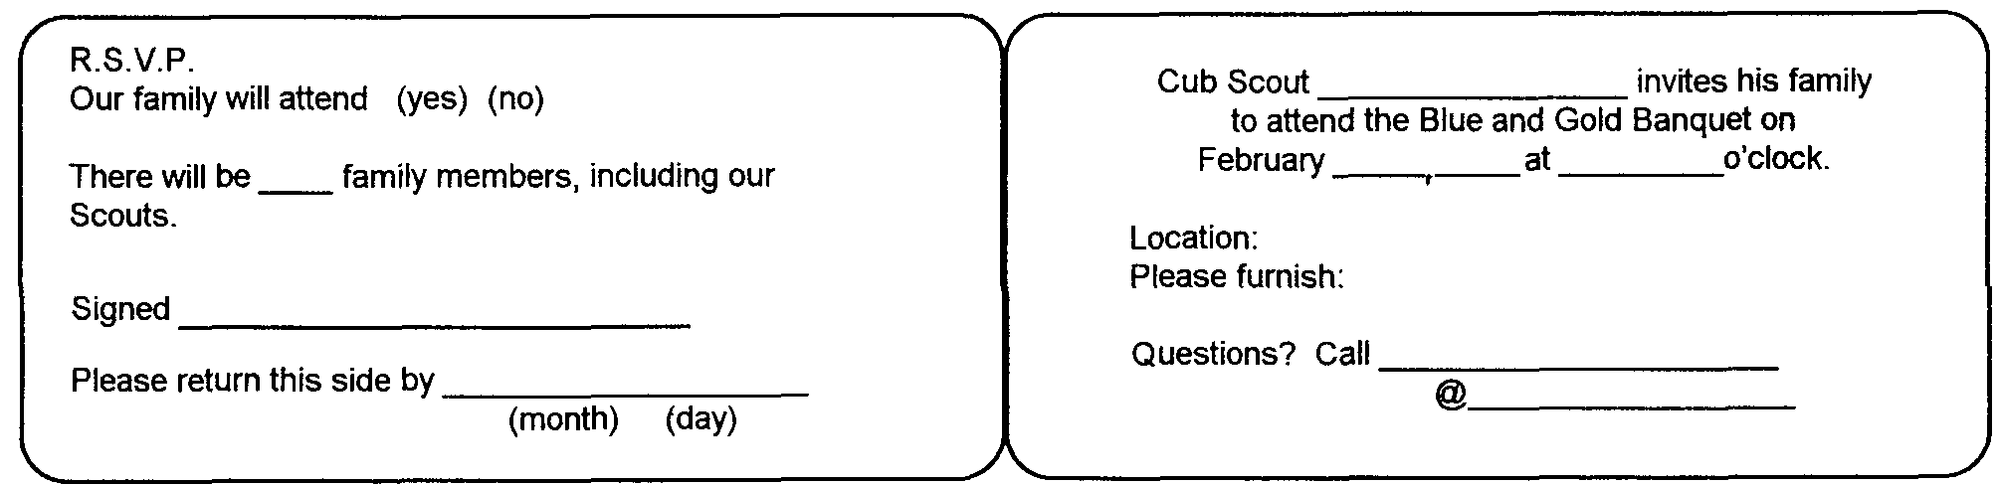

PATTERNS FOR PLACEMATS OR MASKS

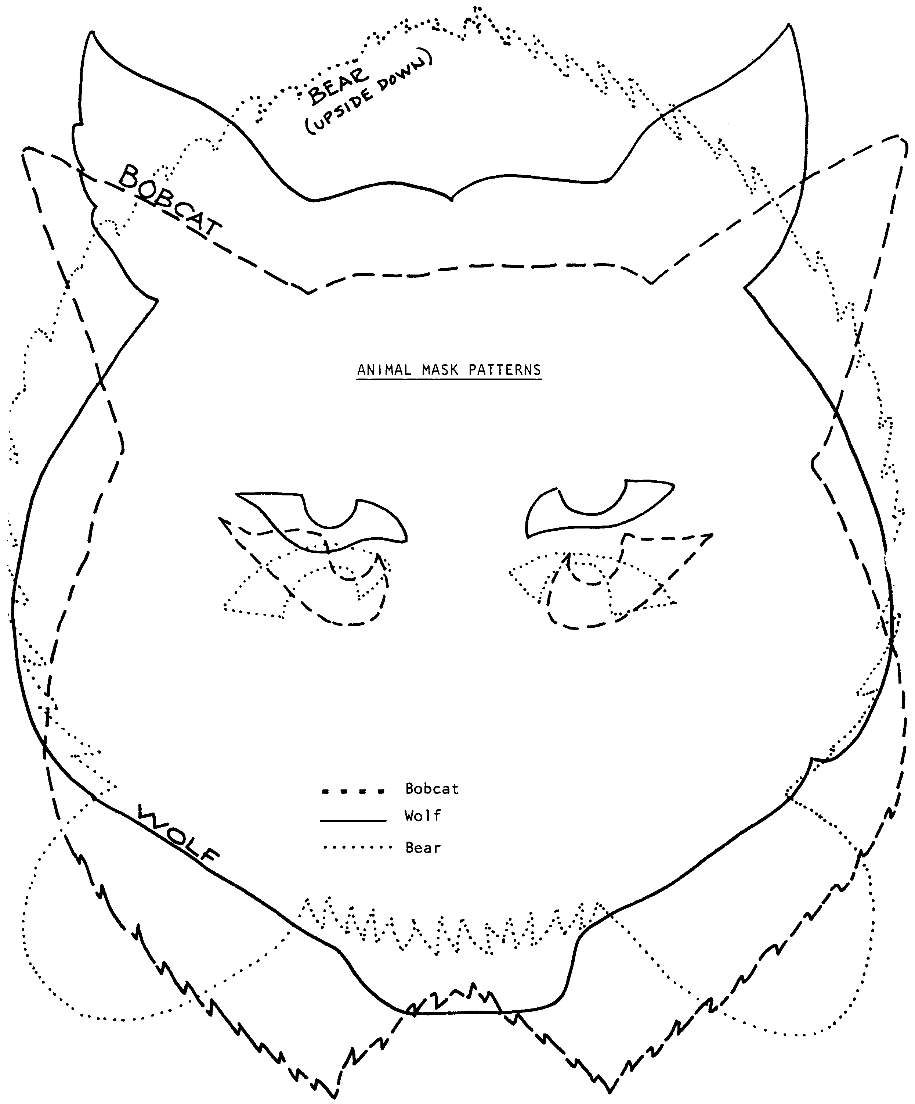

Have this page copied three times and cut
out or draw around the pattern you need.

Use the following lines for animals:

Enlarge for placemats.
NAPKIN RING/BOOK MARK

Materials -- Pellon, construction paper, plastic or other suitable book mark material approximately 2" x 7"; crayons or paint; paper fasteners

Directions -- Draw design on pellon and color; identify den and pack number, occasion and date; cut out book mark; roll into napkin ring and fasten with a paperclip.
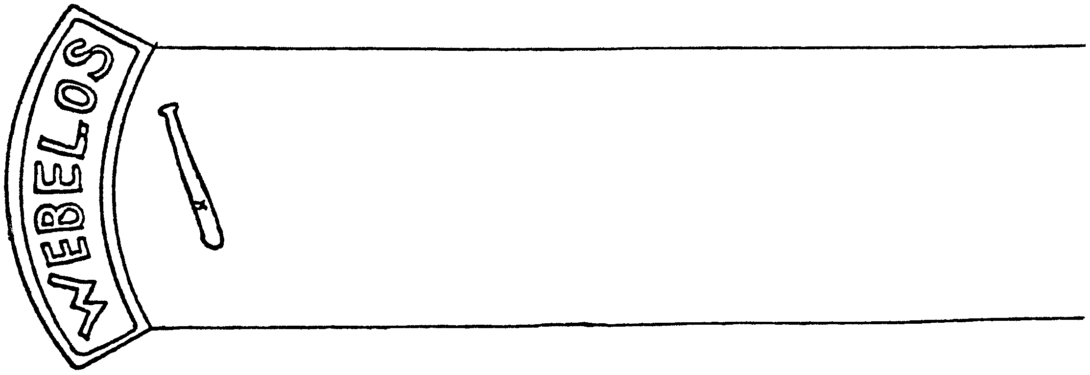

NAPKIN RINGS
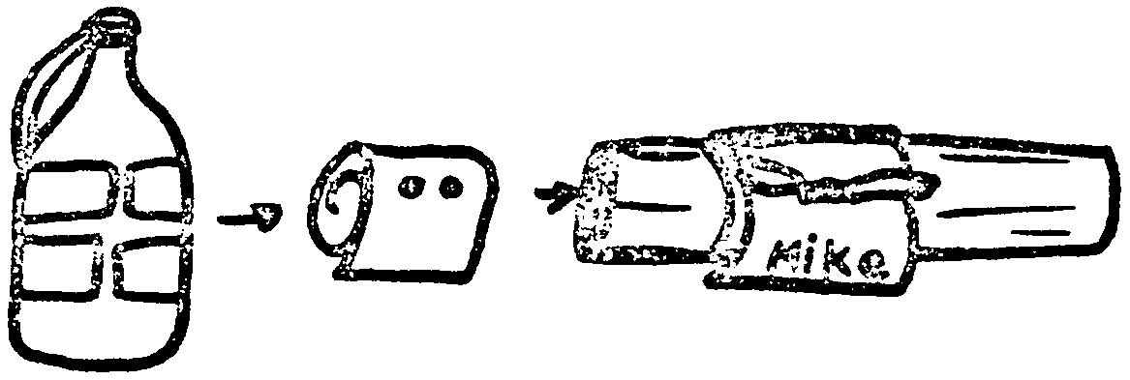

Cut strips from a plastic container. Roll tightly and secure with rubber bands. Heat a nail (Adult should do this - REMEMBER - the whole nail gets very hot). Perforate to the center of the roll. Lace a piece of ribbon through the holes.

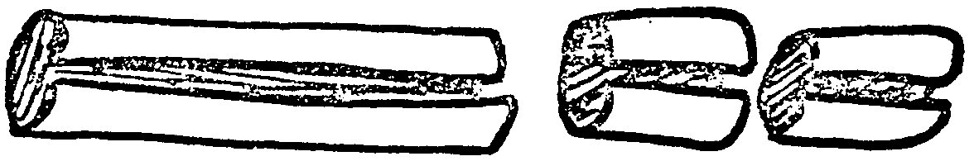
The best way to make a napkin ring from a tissue or paper towel tube is to cut down from the middle and then cut across.

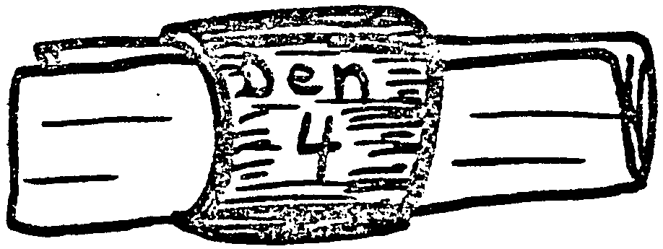


Cover cardboard ring with a piece of scrap material (leather, gingham, felt, burlap, etc.), paper, or paint.

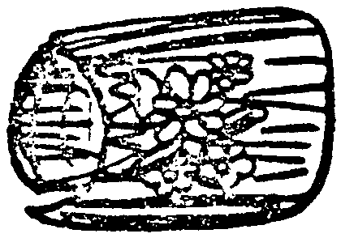
Glue toothpicks to cardboard ring. When dried, you can spray with clear acrylic paint.

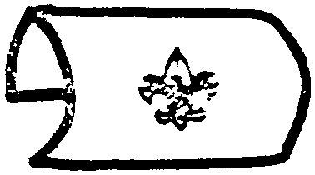

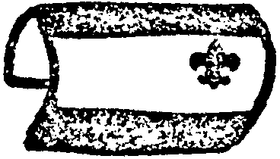
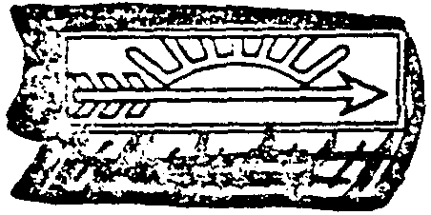


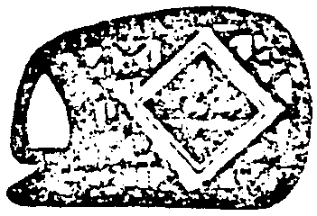
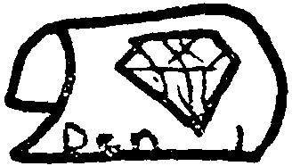
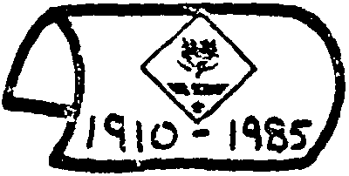
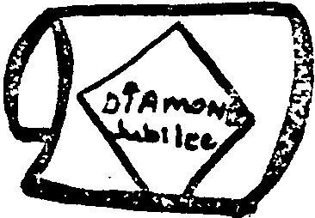



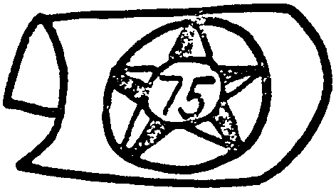

Dip a long strip of crepe paper into a water and glue solution. Wind around the cardboard ring. Decorate dried ring with a small flower cluster or shells.

Examples of plastic or cardboard napkin rings.
Clipart designs add a polished appearance.

BEADED CUB SCOUT

Have each Scout make one for the Blue and Gold Banquet!

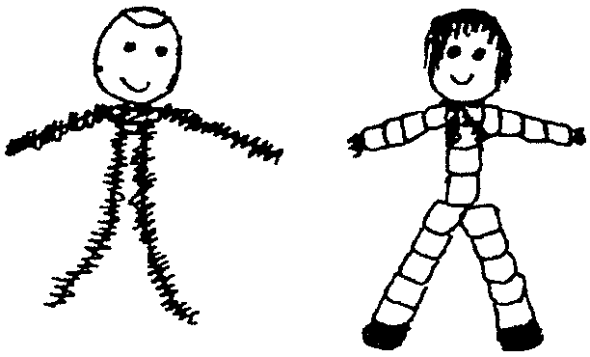
Materials: 20mm wooden bead for head
Two black pony beads
22 blue pony beads
2" yellow chenille stem
31/2" tan chenille stem
8" black chenille stem
Fine-line markers: black, red, eye and hair colors of choice
1/2" x 2" white cardboard scrap
Thick craft glue
Scissors

Instructions:

Make the head and arms. Fold black stem in half. Dip 1/2" of folded end in glue and push on head bead. For arms, wrap center of tan stem around doubled black stem 1/4" under head bead. Push four blue beads onto each arm. To make hands for holding beads on arms, cut ends of tan stem to 1/4". Turn ends up and over last blue bead.

Make the body and legs. For body, hold together both black stem ends that extend from bottom of head bead. Push 4 blue pony beads over both stems. For legs, pull ends of black stems into an upside down "V" shape. Push 5 pony beads onto each black stem. For shoes, push 1 black pony bead onto end of legs. To hold shoes on, cut ends of black stems to 1/4". Bend ends to the back and over black beads.

Finish up. See photo. Use markers to draw hair and facial features as shown. For kerchief, bend yellow stem around neck and extend ends. Bend figure into sitting position. For place card, write Scout's name on cardboard. Wrap hands around card.

PLACECARD

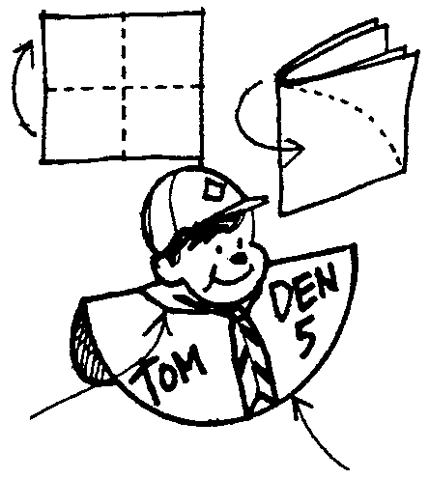
Use a 4" square of paper.
After folding, cut arc in paper...then unfold to create half circle.

Cub Scout head from a photo or comic strip figure pasted on.

CLOTHESPIN PLACECARD HOLDER

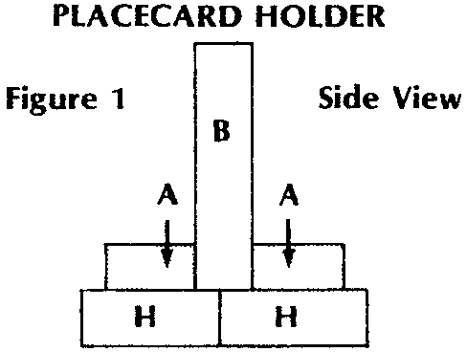
Each card holder will require 4 clothespins cut up into 2 part H, 2 part A and 1 part B (whole clothespin.) Glue two part H end to end. Glue Part B in an upright position directly over the join mark. Glue one part A flush up against part B on either side (resting on part H). Look at Figure 1. Allow to dry completely. Paint the holder blue and gold.

After the banquet, use as a memo holder by the phone.

3D PLACEMARKER
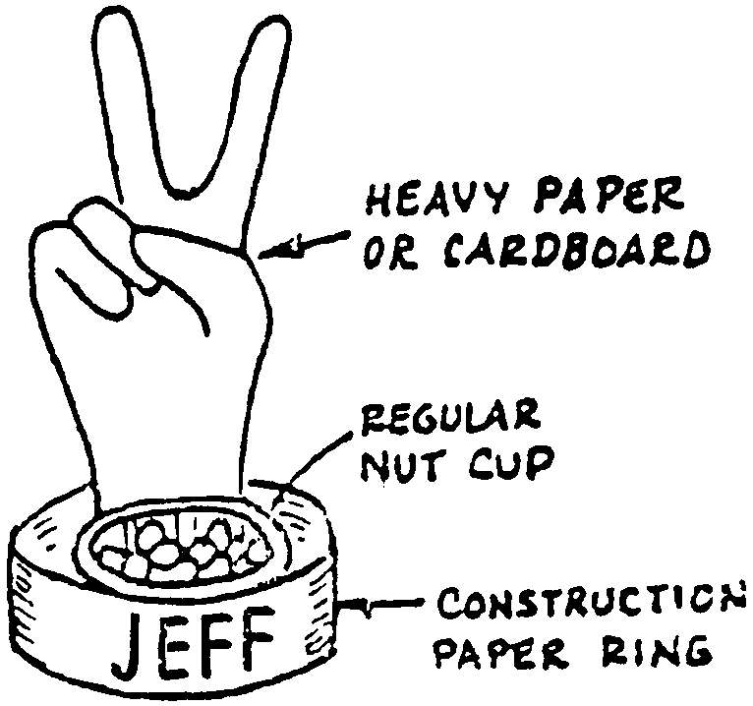

Trace hand on heavy paper and include the wrist. Don't spread the fingers very far apart. Cut-out the tracing. Bend the small and ring fingers so that they touch and tape together on the underside. Bend the thumb and glue it to the bent fingers. Make a cuff from a 1" x 9" strip of construction paper. Print name on the strip and then glue it into a ring shape. Glue the hand to the inside of the cuff. Complete the placemarker with a nut cup.

FLAG PLACECARD

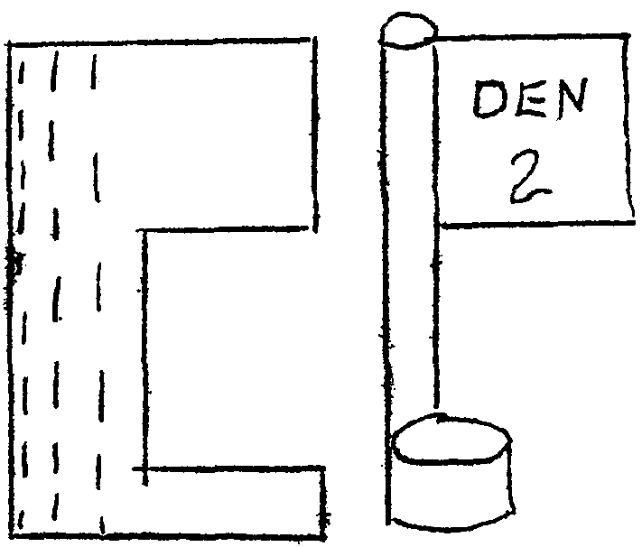
QUICK PAPER FLAGS can be made by folding a rectangular piece of construction paper in half. Crease then unfold. Cut out a section from one end. Decorate "flag area." Roll the other end of the rectangle to form a flag pole. Next roll the base part to form a stand. Glue is applied to the last roll of the pole and to the end of the base. Use various of these quick flags to display historic flags or den flag.

Write person's name on the flag base.

TABLE FAVORS

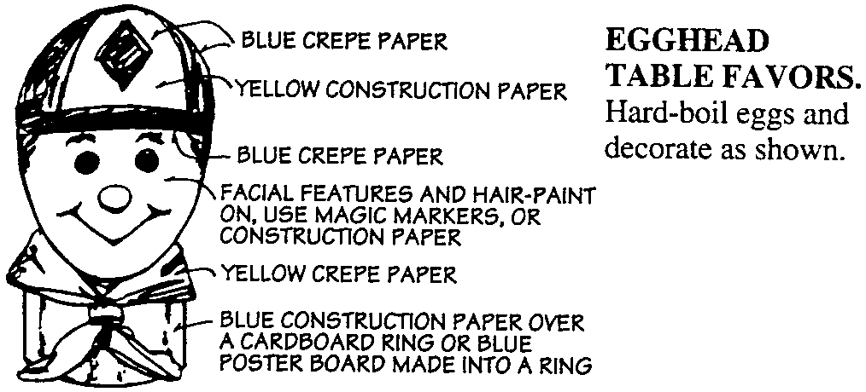

CUB HAT (OLD FASHIONED) BANK

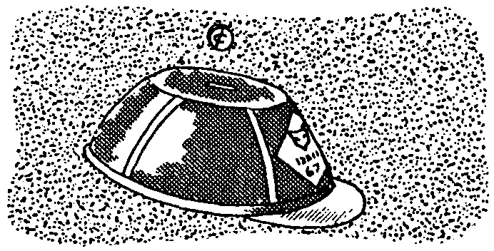
This Cub hat makes a cute table decoration for the Blue and Gold banquet; afterward, use it for a bank. For the crown, use a plastic margarine or dessert topping container with its lid; paint with blue acrylic or enamel paint. Add yellow "seam" lines with yarn or adhesive-backed paper. Cut a brim from blue paper and glue in place. Add paper insignias or emblems. Cut a slot in the top for coins. Change the color scheme to make the hat more up to date, if you wish.

CENTERPIECE

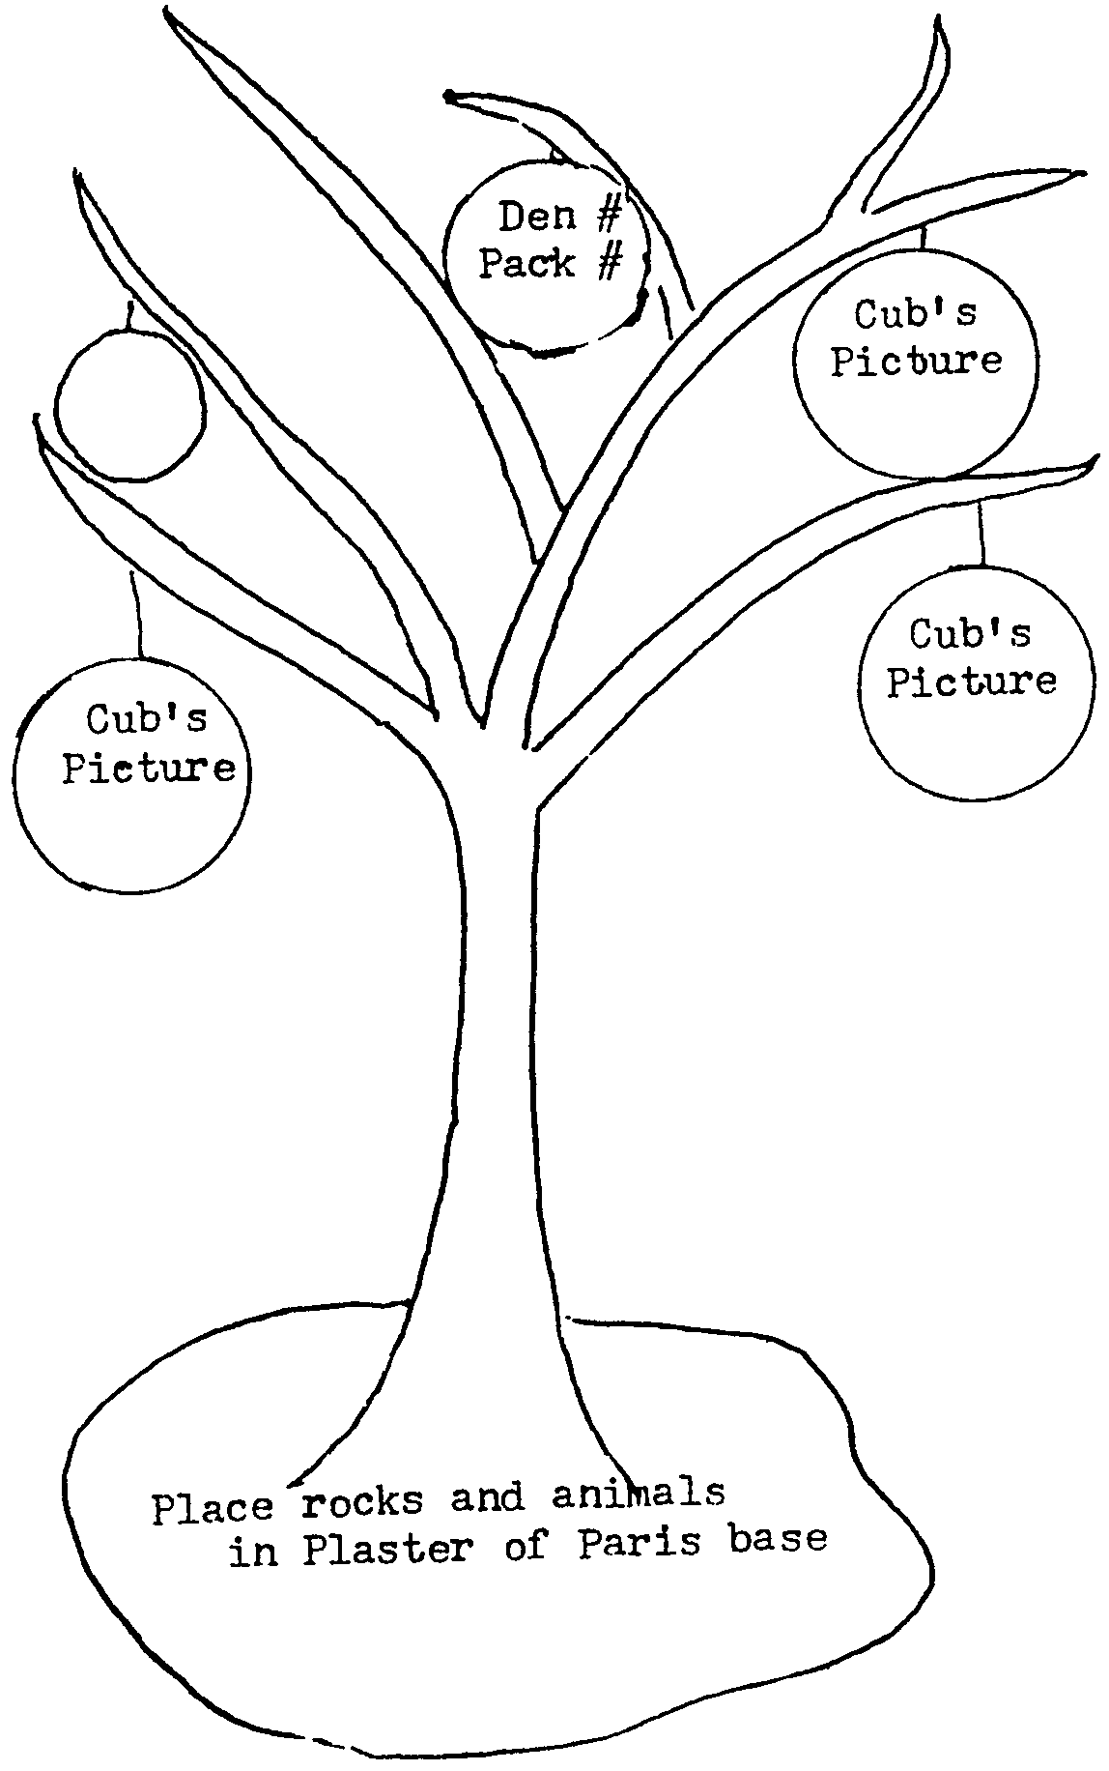

Spray dry twig with clear shellac or paint. Hang den number, pack number and pictures of the boys on it.

For additional Blue & Gold craft ideas see the Cub Scout Leader How-To Book, pages 9-53 and 9-58 to 9-62
CENTERPIECE

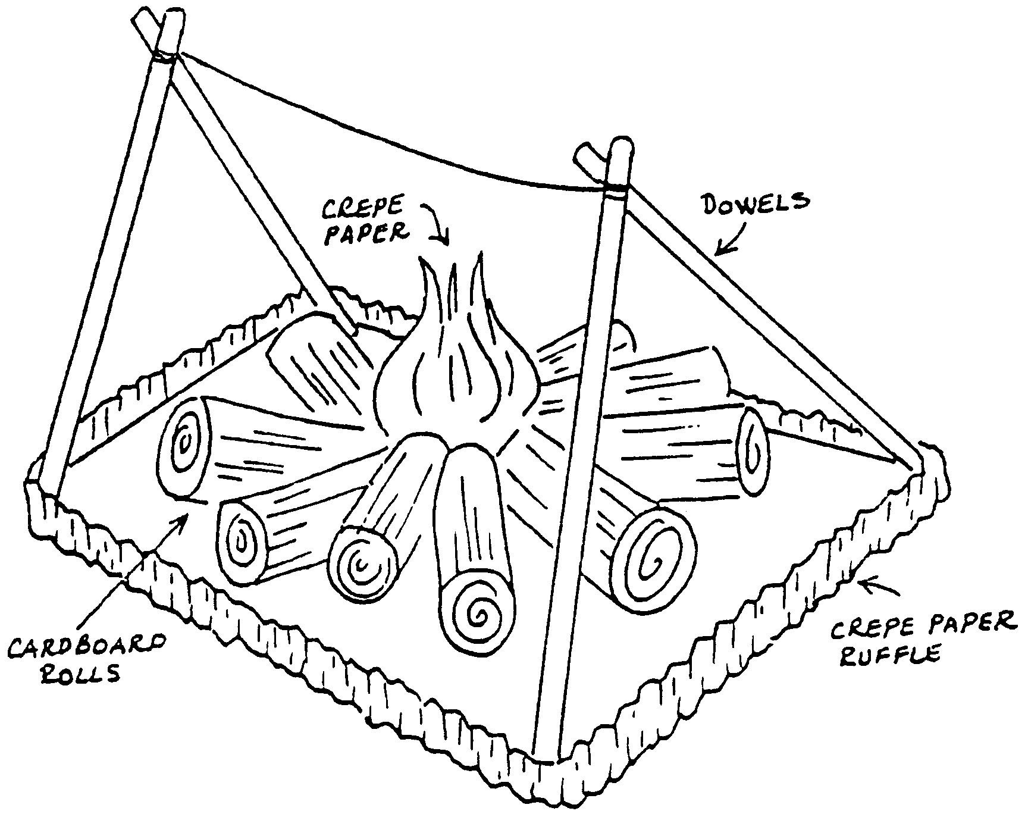

Webelos Scouts will like this centerpiece because it reminds them of something they like to do -- camp.

Seal the ends of cardboard rolls with brown paper tape. Cover the rolls with crumpled brown paper, using a fine-line marking pen to make markings resembling bark. Flame is a chicken-wire base covered with red and yellow crepe paper.

Campfire is assembled on a decorated box lid. Dowels, lashed together at the top are used for supports. You may wish to hang a miniature pot over the fire.

Napkin rings, place cards and favors can all be made in the shape of logs to match the centerpiece.
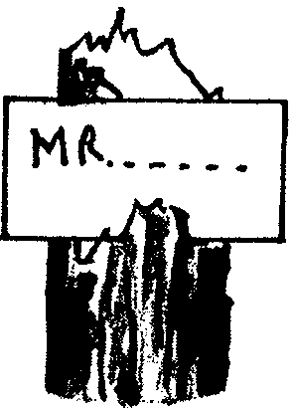
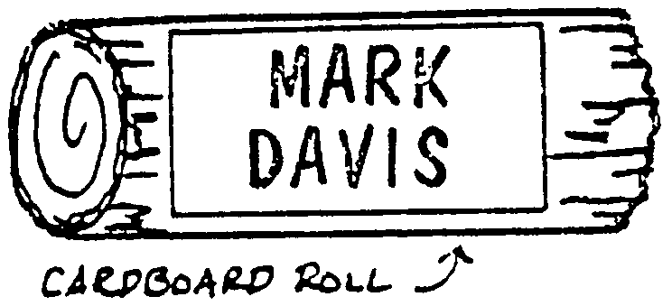

twig

Placemats could be a construction paper rectangle (12" x 16") with a cutout of a campfire glued on it.
BLUE AND GOLD SLIDE

Cut each letter out of felt and a 2-1/2" x 1" piece for the back
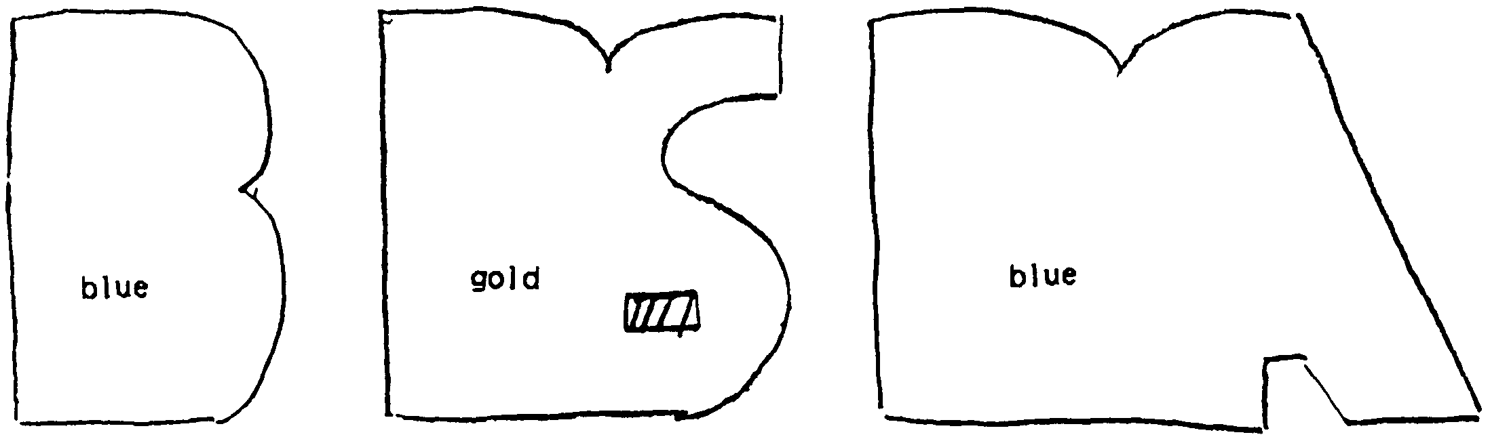


Stack letters on top of the back piece and push paper brads through all three letters and the back piece at the 'x' marks.
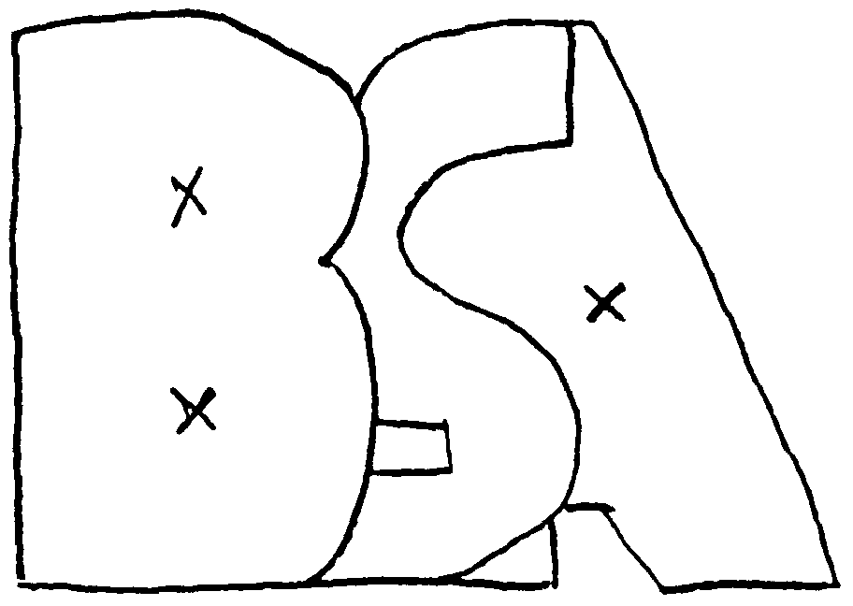

Neckerchief goes between the 'A' and the back piece.

'WHIPPED' NECKERCHIEF SLIDE

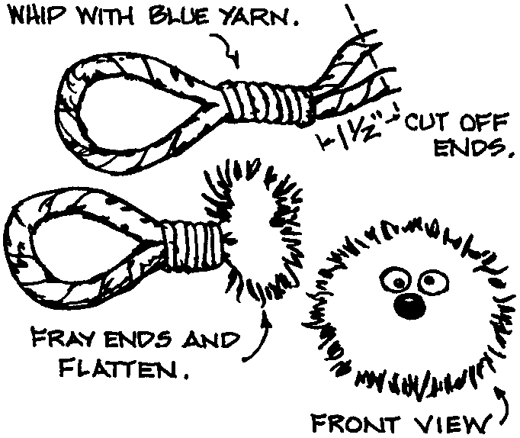
Cub Scouts working on Bear Achievement 22 can practice whipping a rope and make a neckerchief slide at the same time. Make a loop in a length of yellow macramé cord and whip it with blue yarn as shown or reverse the colors. Then fray the ends and hot-glue on wiggly eyes and a tiny red pompom nose. "Maxi-cord" works well. If the cord is too thin, use three strands and braid them. This makes the "face" fluffier.

BLUE-N-GOLD POPCORN
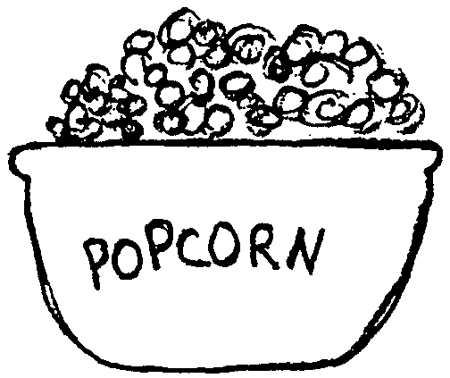

2 cups sugar
1 Tbls. white corn syrup
1/4 tsp. salt
2/3 cup milk
1 tsp. vanilla
Blue and Yellow food coloring
6 quarts popped popcorn

Mix first four ingredients and cook to 230 degrees on candy thermometer. Remove from heat, add vanilla and one color of food coloring. Pour slowly over the popcorn, stirring to coat all the popcorn. Spread on wax paper to cool. Store in a canister or big bowl. Make a second batch for the other color.

LONDON BUNS
(A favorite of British schoolboys)

1/4 cup sugar
1 egg
3/4 cup milk
2 cups Bisquick
1 cup raisins or currants
1/2 cup candied fruit (3 oz.)
2 Tbsp. vegetable oil or melted margarine

Heat oven to 400° (mod. hot). Blend all ingredients; beat vigorously for 30 seconds. Fill greased muffin cups 2/3 full. Bake 12-15 minutes or until golden brown. Serve hot. Makes about 20 small or 15 medium muffins.

KNOT ROLLS

Cut one loaf of frozen or refrigiator bread dough into 8 strips. Tie each strip into a square knot or overhand knot or a twist (see diagram). Brush with beaten whole egg and sprinkle with sesame or poppy seeds. Cover with plastic wrap and let rise until double in bulk. Bake at 350° for 20 minutes.


1. Make a loop.


3. Put other end of dough in center, going the opposite way.

2. Put one end of dough through center.
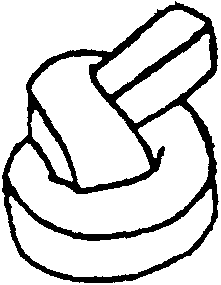

4. The roll will look the same on both sides; a little nubbin of dough (the end of each strip) will be in the center.

SUPER KISS

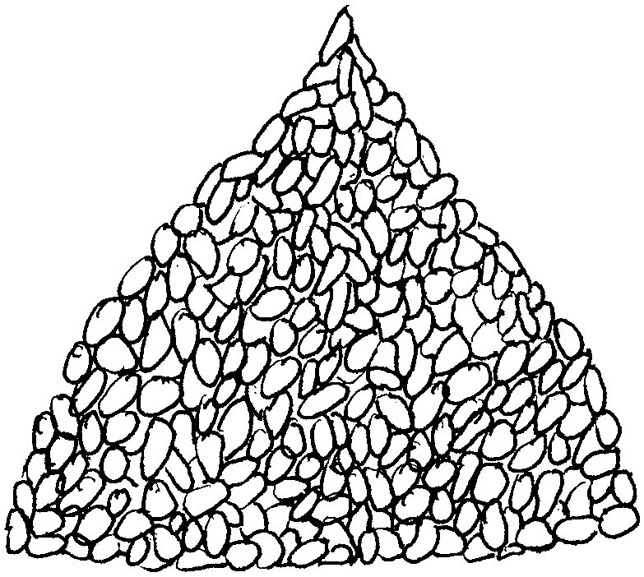
MATERIALS: (makes two to four kisses)
Butter or margarine, 1 stick
Miniature marshmallows, 1 package, 16 ounces
Plain or chocolate crisp rice cereal, 12 cups

EQUIPMENT:
Large plastic kitchen funnels, two or more
Ribbon of choice
Large saucepan, large spoon
Cookie sheet, plastic wrap
Scissors, measuring cup

INSTRUCTIONS: Coat inside of plastic funnels with butter or margarine and cover cookie sheet with plastic wrap; set both aside. Melt butter or margarine in saucepan over a low to medium heat; add marshmallows. Heat until marshmallows are completely melted, stirring constantly. Remove from heat and add cereal; stir until cereal is well coated. Cool slightly, but not completely. Lightly butter fingers; press mixture into plastic funnel. (Note: Using more than one funnel at a time will speed up shaping process.) Place filled funnel on plastic-covered cookie sheet. Let cool. Unmold kiss and cover with plastic wrap. Use ribbon to tie top of wrap closed.

GOLD ALMOND PUNCH

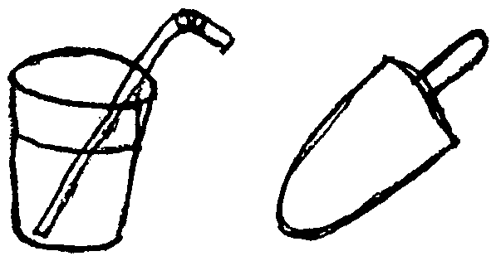
1 12 oz. can frozen orange juice
1 12 oz. can frozen lemonade
3 cups sugar
2 tsp. vanilla
I tsp. almond extract

Mix all ingredients together, add ice, serve. Also makes yummy popsicles or slush.

See the Cub Scout Leader How-to Book for
"Blue and Gold Mints" (p. 9-61)

